

[Document title]

Assignment (Group: Navneet_01)



|  |  |
| --- | --- |
| **MEMBERS LIST** | |
| **Institution** | **Melbourne institute of technology** |
| **Bibek Lamichhane** | **MIT213769** |
| **Chiran Bhujel** | **MIT210970** |
| **Gyanendra Gautam** | **MIT220162** |

Table of Contents

Introduction 1

Project Significance 2

Review Specific Client Needs 2

Determine What Servers and Server Functions (Services) Will Be Needed and Suggest Solutions 2

Supply the Necessary Scenario Configurations 3

Network Design 3

Installation and Configuration Process 4

Domain Parent Server (Adding Roles and Features) 8

Complete post-deployment configuration 12

DHCP Configuration 15

Ethernet Configuratioun 16

Define IP Address Ranges 17

Instructions for creating an OU in Active Directory and assigning users, machines, and groups to it 25

To quickly connect a GPO to an OU in Active Directory 27

Privilege Assignment 30

The Setup of an IIS Server 38

Installation of child server 40

Configuration on child server(Ethernet) 43

FOR RELIABILITY AMONG SERVERS 44

Make sure the Child Domain has an Active Directory Integrated Zone: 47

Configure Forwarding DNS Record 49

Delegate the DNS sub domain on the parent domain 53

Table of server 56

Conclusion 57

References 57

# Introduction

**Overview of the Project**

Melbourne magic equipment supplier Magic_Reality upgraded its LAN. This initiative aimed to boost production, safety, and growth. The project delivered a centralised user authentication system, DHCP-based IP address assignment, and an IIS server to host the company's website. A detailed network diagram, setup instructions, rights, and troubleshooting guide were given in this documentation report. Data protection and corporate continuity were planned using backup and disaster recovery protocols. This effort shows Magic_Reality's commitment to using technology to improve efficiency and competitiveness.

The firm has 50 employees in Gadgets, Finance, and Sales. The Gadgets section has 15, accounting 15, and sales 20 employees. Magic_Reality will create OUs for each department in Active Directory to categorise and arrange network resources. The company also wants many Windows Server domains to safeguard and manage its networks and meet their IT demands. The management of domain rules, resource allocation, and user accounts will be simplified.

# Project Significance

The project is important because it will help us accomplish the following:

* Authentication of users across domains is centralised.
* IP addresses are assigned automatically by the DHCP server.
* The use of a committed IIS server for the business's website hosting needs.
* Separation of functions by creating separate domains for administrators and users.

# Review Specific Client Needs

Magic_Reality is a client profile of a Melbourne-based magic equipment supply company. They employ 50 people across three divisions—Gadgets, Finance, and Sales. The following specifications must be met in order to set up their LAN:

* To streamline user administration and permissions, Magic_Reality requires centralised authentication for all domains.
* To guarantee effective network administration, automated IP address assignment through DHCP is required.
* Webpage of the Host Organisation: The firm is hoping to boost its internet visibility by having its website hosted on a dedicated IIS server.

Magic_Reality plans to have two distinct domains, one for administrators and one for normal staff members. Separation like this is essential for safety and management of access.

# Determine What Servers and Server Functions (Services) Will Be Needed and Suggest Solutions

**Controllers of Domains**:

Active Directory and centralised user authentication rely heavily on domain controllers, which play a number of important roles. Both an administrator domain controller and a user domain controller are required for Magic_Reality to function properly.

Create organisational units (OUs) for the three divisions (Gadgets, Finance, and Sales), configure Active Directory on these servers, and establish domain rules for user administration.

**Domain Name System (DNS) Servers:**

Functions: DHCP servers are essential as they assign IP addresses automatically.

To configure, create two DHCP servers, one for the Administrator Domain and one for the User Domain. Adjust IP address ranges as needed.

**Web Server: IIS**

Functions: The Company’s website must be hosted on an IIS server.

Install and set up IIS on a standalone server. Maintain the corporate website by adding and editing files.

**Domain Name System Servers:**

Domain name servers' primary function is to resolve Internet addresses inside a local area network.

DNS must be configured on all domain controllers. Make sure external DNS resolution is set up by creating DNS zones for the domains and setting up DNS forwarding.

# Supply the Necessary Scenario Configurations

* Active Directory Setup: Install and configure Active Directory on all domain controllers; establish organisational units (OUs) for each department; assign users to groups; configure group rules.
* Set up the Domain Name System (DNS), configure the DHCP server, and activate DHCP relay if needed; this is the DHCP configuration.
* Set up IIS on the selected server and configure it as needed. Put the finishing touches on the corporate website by uploading the files and configuring the bindings.
* Set up DNS on the DCs, establish DNS zones for the domains, and configure DNS forwarding so that external resolution may take place.
* To provide appropriate access control in both spheres, it is necessary to define security rules, group memberships, and permissions.
* Backup and Disaster Recovery Procedures: Critical Servers and Domain Controllers Should Be Backed Up Regularly. Make plans for data protection and business continuity in the event of a catastrophe, and record those plans.

Magic_Reality can set up a reliable, well-managed LAN for its operations if it meets the needs of its customers and adopts the recommended server roles and configurations.

# Network Design

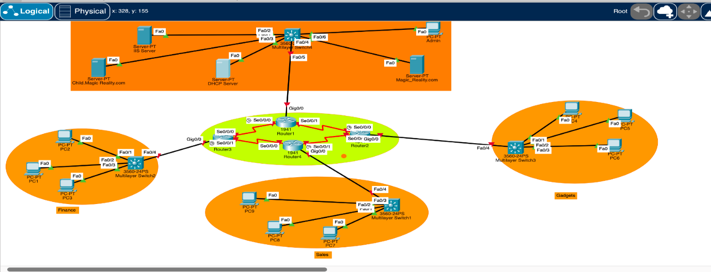

FIG: 1 Network Diagram (Source: CISCO Packet Tracer)

The routers, firewalls, switches, and servers that make up Magic_Reality's LAN in Melbourne are all carefully placed in the network architecture. This layout improves internal communication, data security, and resource distribution. Multiple domains are created, user authentication is centralised, IP addresses are assigned automatically through DHCP, and the company's website is hosted on a separate IIS server. In addition, a safe and efficient network environment is promoted by domain separation, which allows for granular administrative control and user-level access.

# Installation and Configuration Process

**Main Server: Parent**

Installing Windows Server in VirtualBox requires creating a VM and installing Windows Server. Step-by-step instructions:

Prerequisites:

* Make sure your machine has VirtualBox. Download it at VirtualBox.com.
* Windows Server ISO: Get an official Windows Server ISO file (e.g., 2019).
* Start by creating a virtual machine
* Launch VirtualBox.
* Click "New" to construct a virtual computer.
* Name your VM "Windows Server" in the "Create Virtual Machine" step.

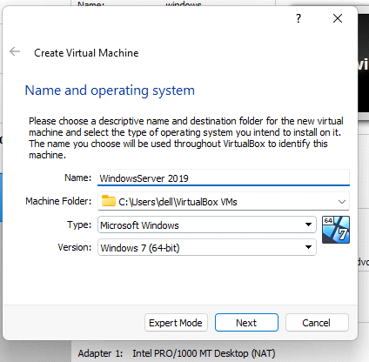

* Select Windows and Windows Server 2019 (64-bit) as the Type and Version.
* Click "Next."
* Step 2: Setup Virtual Machine
* Give the VM RAM. Depending on system resources, assign 2 GB or more. Click "Next."
* Virtualize a hard drive. Select "Create a virtual hard disc now" and click "Create."
* Choose VDI as the hard disc file type and click "Next."
* Dynamic or fixed-size storage. For flexibility, dynamic allocation is advised unless you need a fixed-size disc. Click "Next."
* Set the virtual hard disc size. At least 40 GB is needed for Windows Server, although you can add more. Click "Create."
* Step 3: Attach Windows Server ISO
* Right-click your newly formed VM in VirtualBox Manager and select "Settings."
* Select "Storage".
* Click "Controller: IDE" and the empty optical drive, then the disc icon next to "IDE Secondary Master."
* Select "Add Optical Drive" and select the Windows Server ISO file you downloaded.
* Click "OK" to close Settings.
* Step 4: Install Windows Server
* Select the VM in VirtualBox and click "Start".
* VMs boot from associated Windows Server ISOs. Install Windows Server using the on-screen directions. Language options, time and currency format, and product key are required.

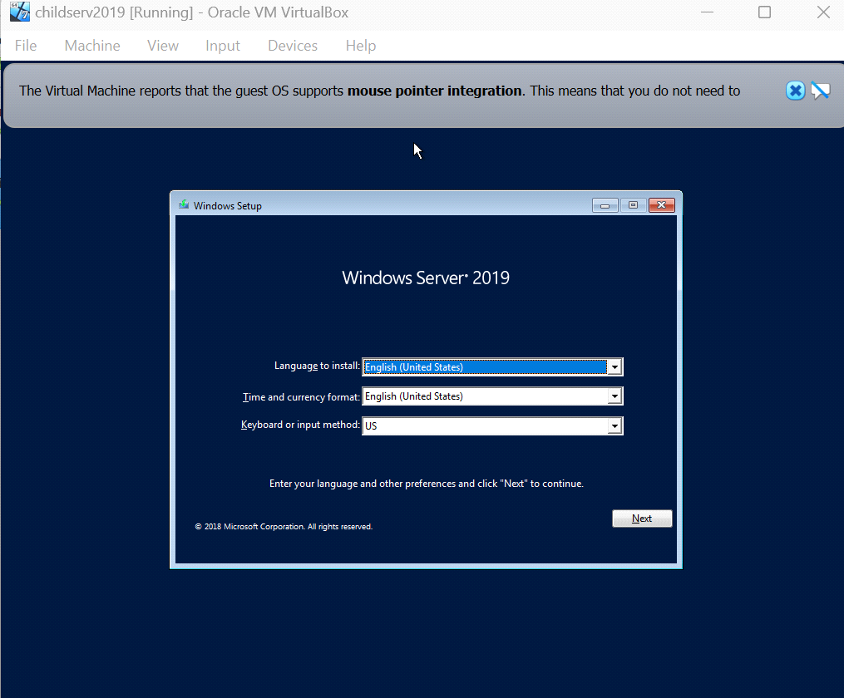

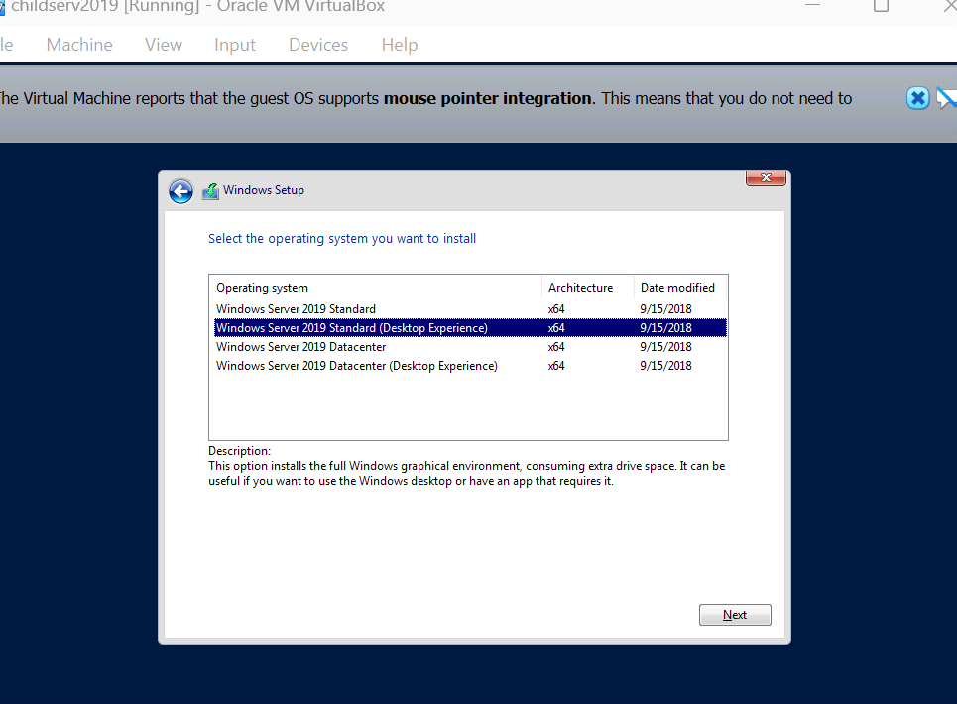

* Set the installation type to "Custom: Install Windows only (advanced)."

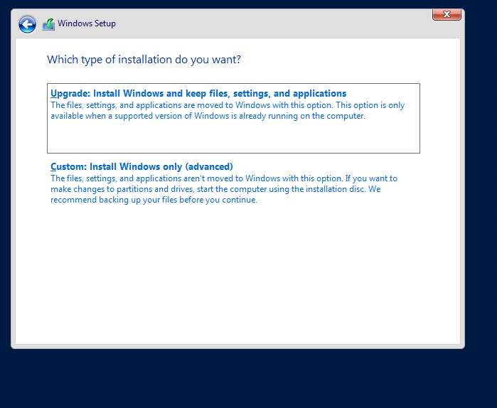

* Install by selecting the virtual hard disc you prepared earlier and clicking "Next".
* Configure Windows Server settings and generate an administrator password following the installation instructions.
* Step 5: Finish Installation
* The VM restarts after installation. Installing Windows Server requires establishing network settings, setting the administrator password, and more.

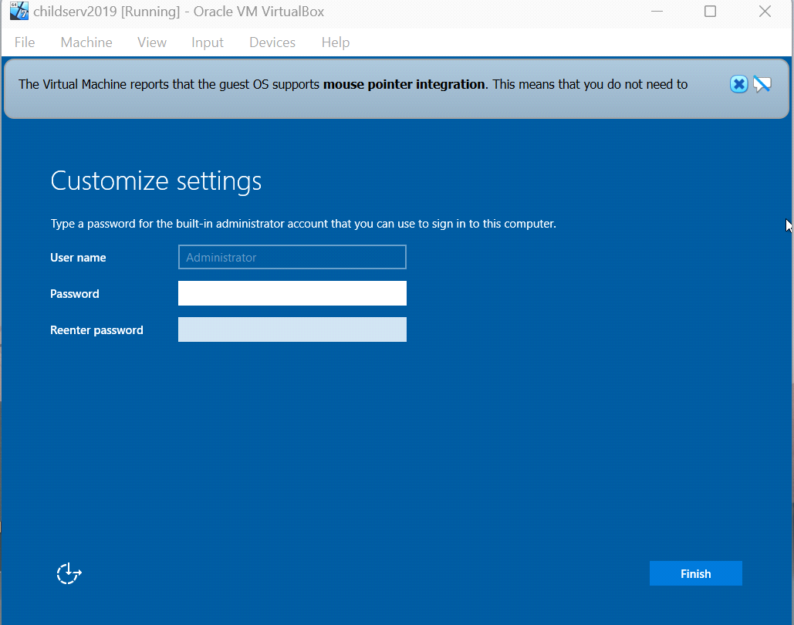

* Virtual Box will operate a Windows Server virtual machine after setup.
* This virtual computer can be used for testing, development, or other purposes in Virtual Box.

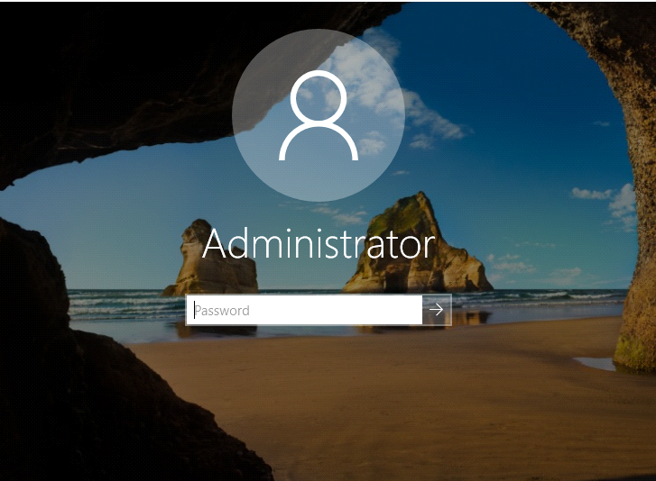

# Domain Parent Server (Adding Roles and Features)

* Access the primary domain server in an administrative capacity.
* Launch the Server Administration Interface.
* Select "Add Roles and Features."

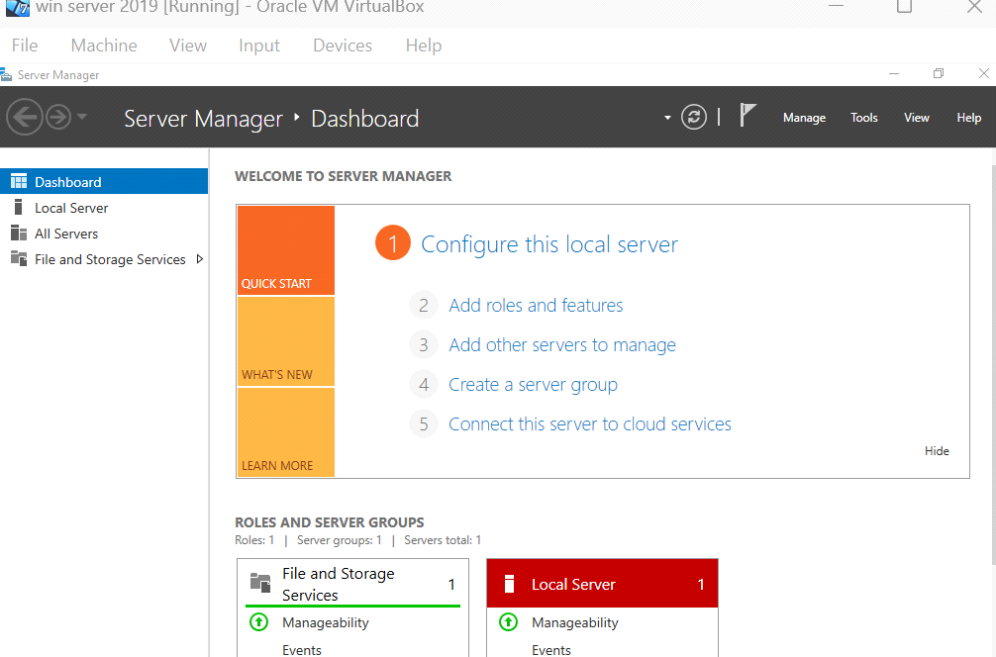

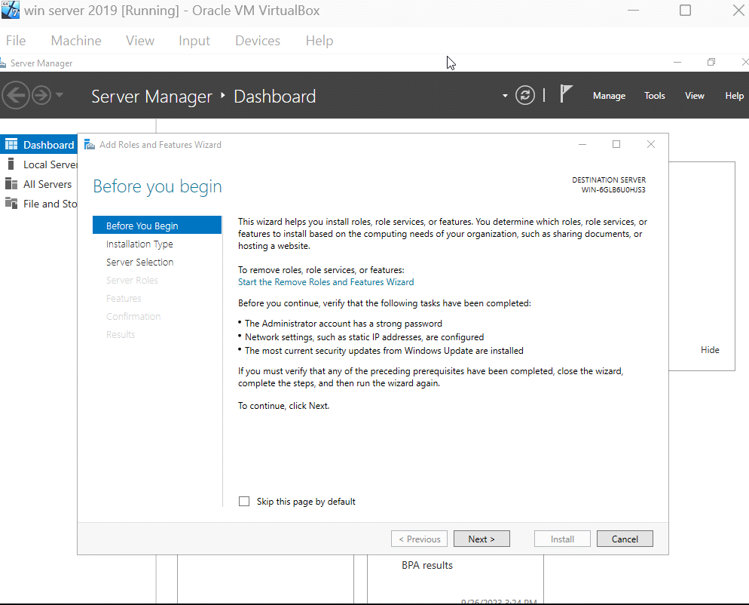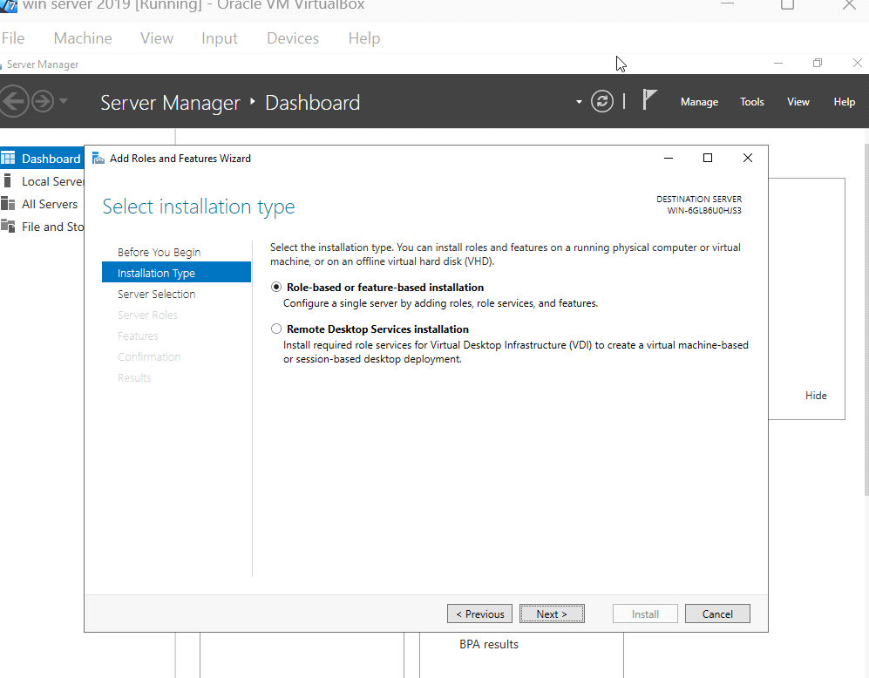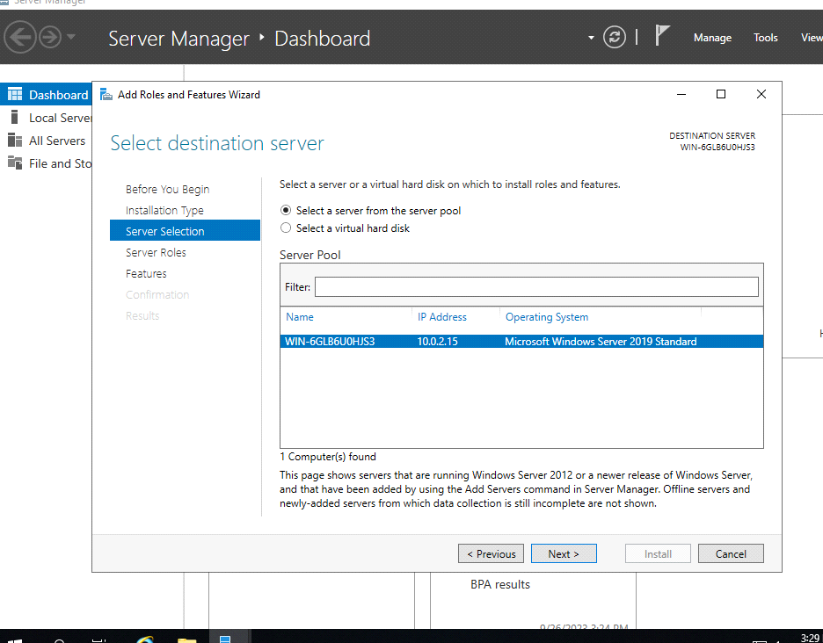

The "Active Directory Domain Services" role can be installed by following the on-screen instructions.

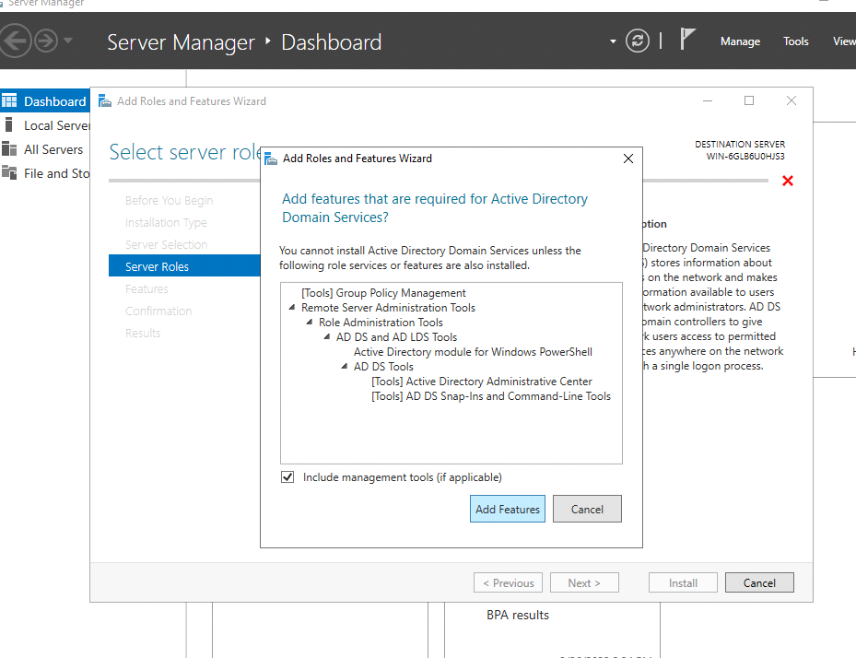

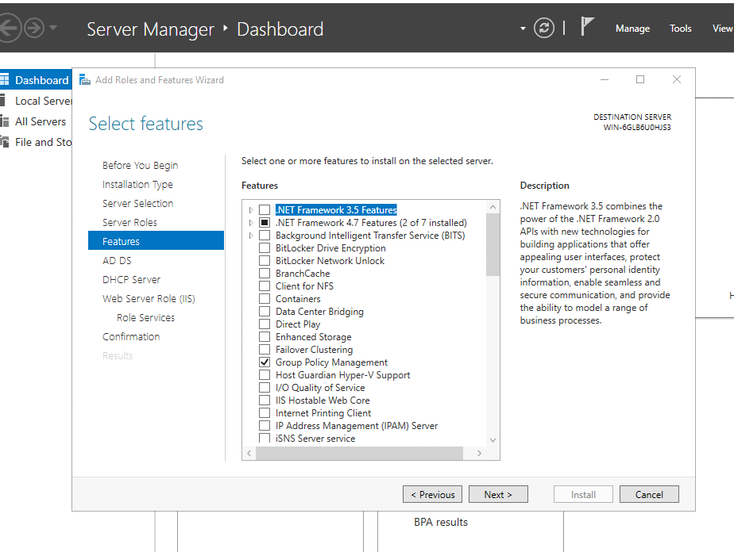

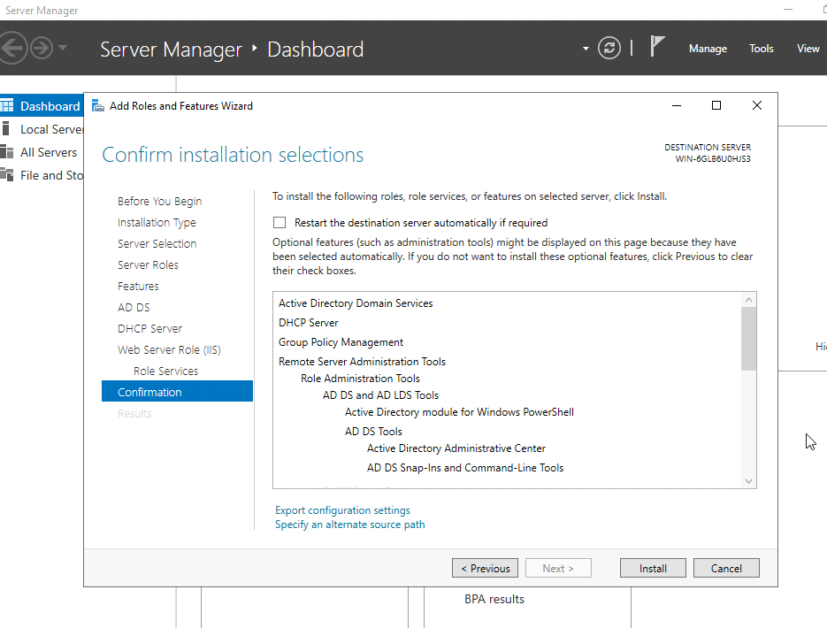

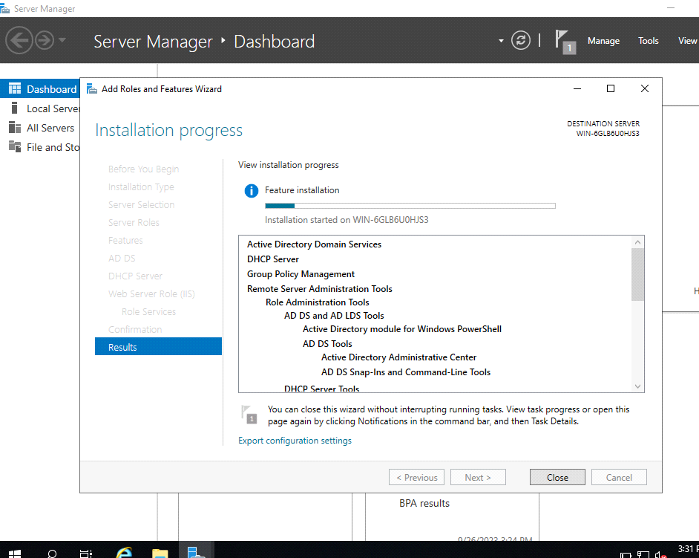

Complete post-deployment configuration

1. Select the "Promote this server to a domain controller" button in Server Manager. 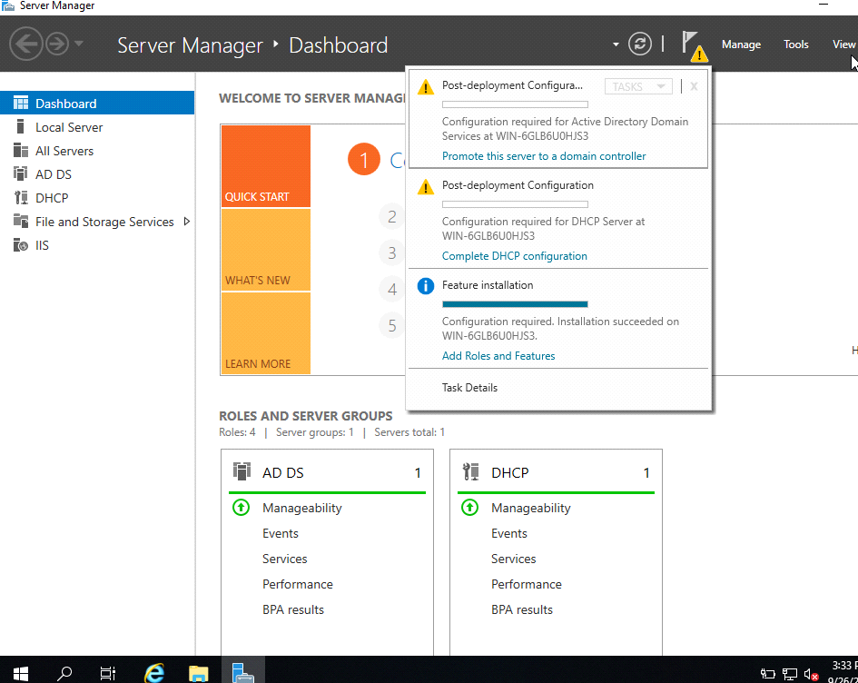
2. Select "Add a new forest" to create a new top-level domain.
3. Enter the top-level domain name (for instance, Magic_Reality.com) and create a password for Directory Services Restore Mode.

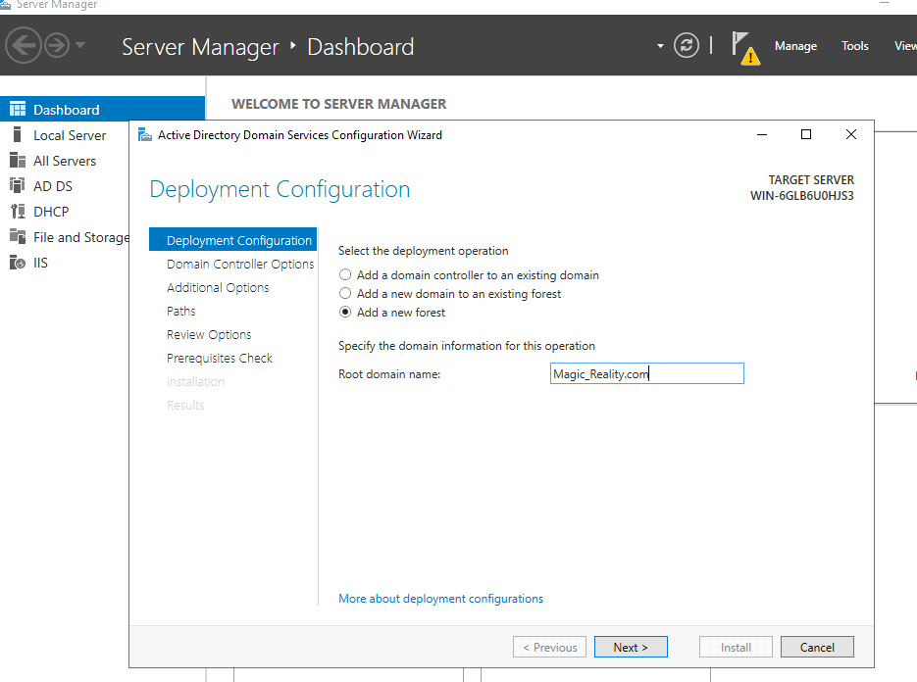

d. Proceed with the wizard's instructions to earn the uplift.

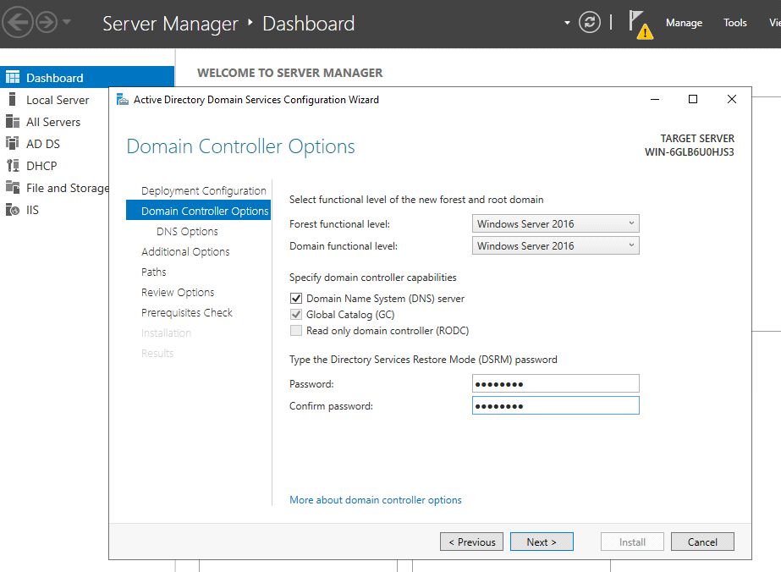

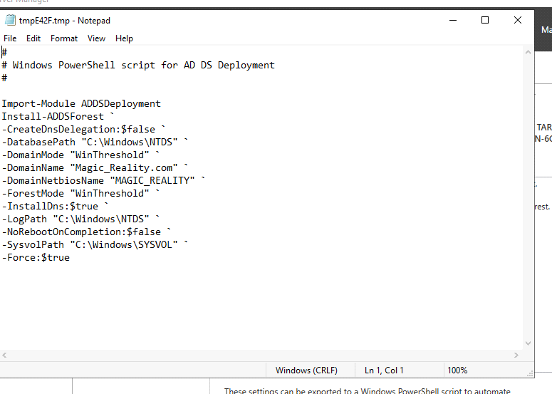

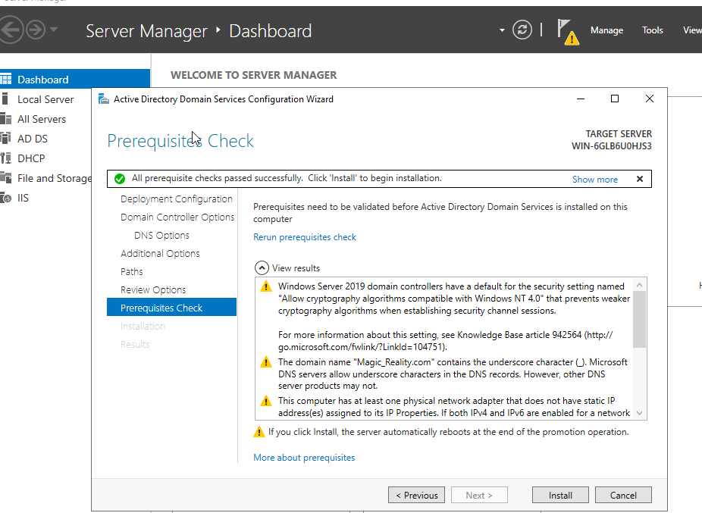

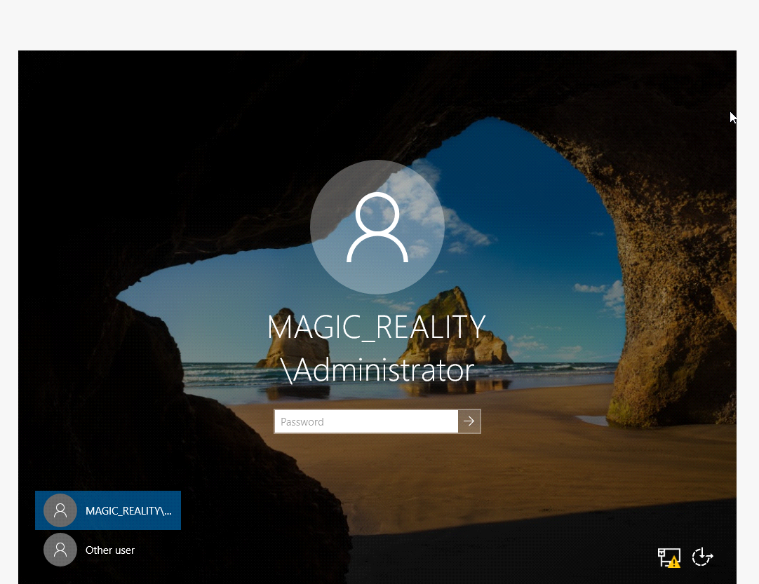

**Essential instructions:**

Host+F to enter full-screen mode

Ctrl+Alt+Del = Host+Del to unlock the screen in scaled mode

To activate Ctrl+Alt+Del, choose "Input" > "Keyboard" > "Insert."

* Launch the Server Administration Interface. To access Server Manager, either double-click its taskbar icon or type "Server Manager" into the Search box in the Start menu.
* In Server Manager, go to the "Manage" tab, then "Add Roles and Features."
* Follow the on-screen instructions, pick "Role-based or feature-based installation," and then select the server you want to use [1].

# DHCP Configuration

* Go to "Roles" and pick "DHCP Server." After clicking "Next" in the wizard, select "Install" to begin setting up the DHCP service.

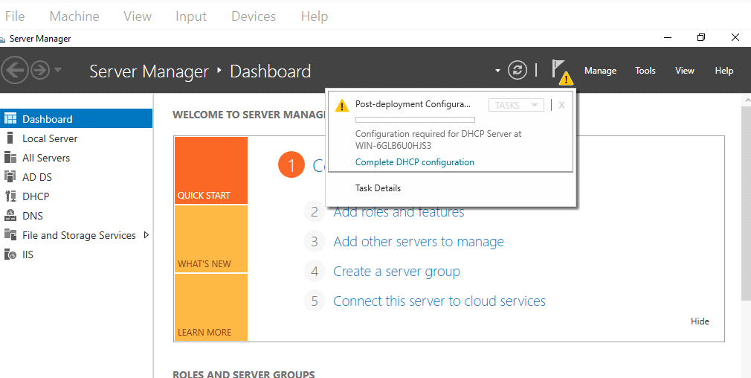

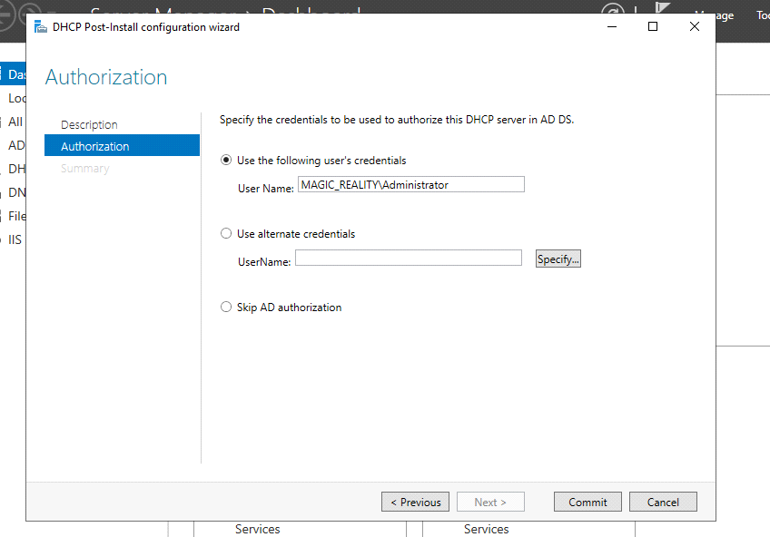

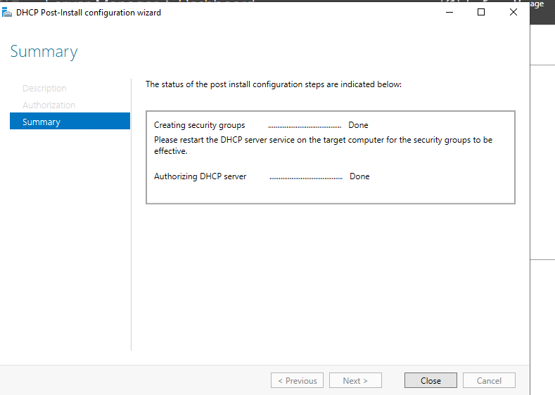

# Ethernet Configuratioun

* Proceed by selecting Local Server > Ethernet > Properties > TCP/IPv4 > Properties.
* In the properties section of the command prompt, enter the IP address of the system and the default gateway address.

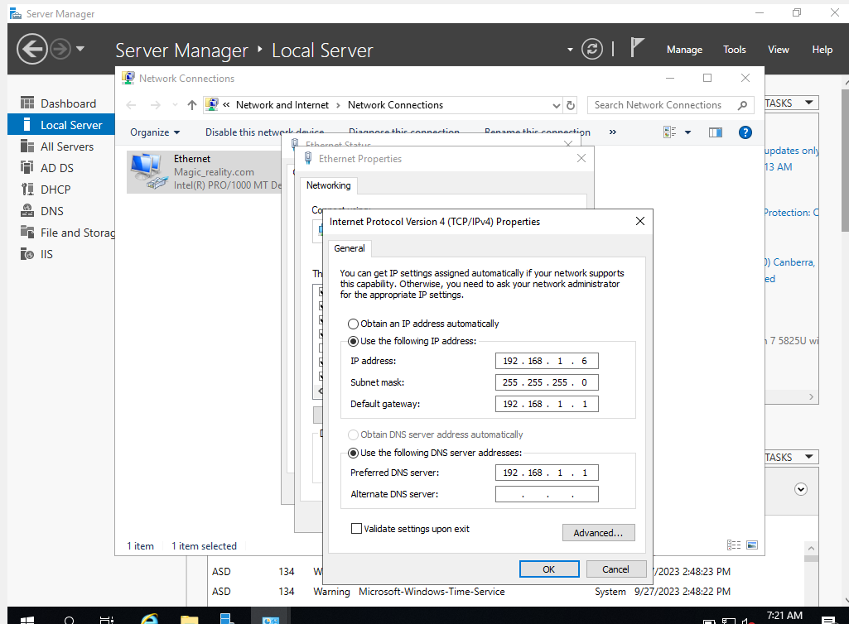

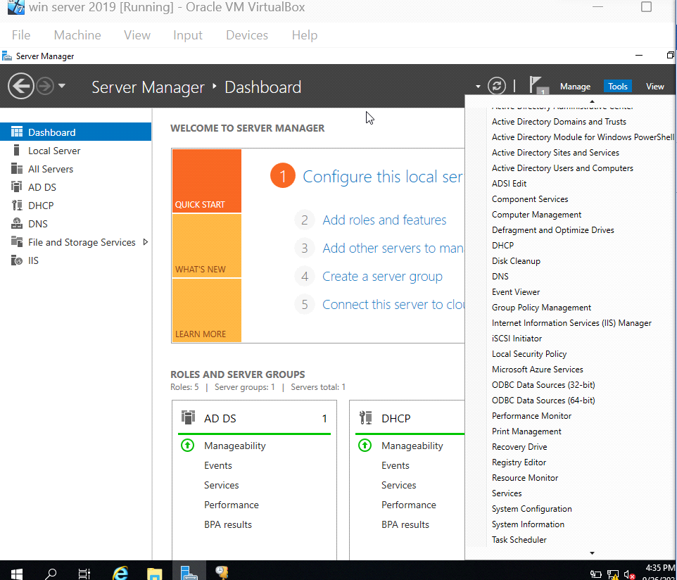

# Define IP Address Ranges

You will be asked to authorise the server if this is the first DHCP server in the domain. For permission, select "Authorise."

Indicate Your Preferred Network:

Choose the network interface that communicates with your DHCP clients in step a. The IP address provisioning network segment must be linked to this adapter.

Step: Select "Next."

**Set Access Levels**:

DHCP scope specifies the range of client IP addresses and server-side configuration options that can be made available by the DHCP server. Just hit the "Add" button to make a new scope.

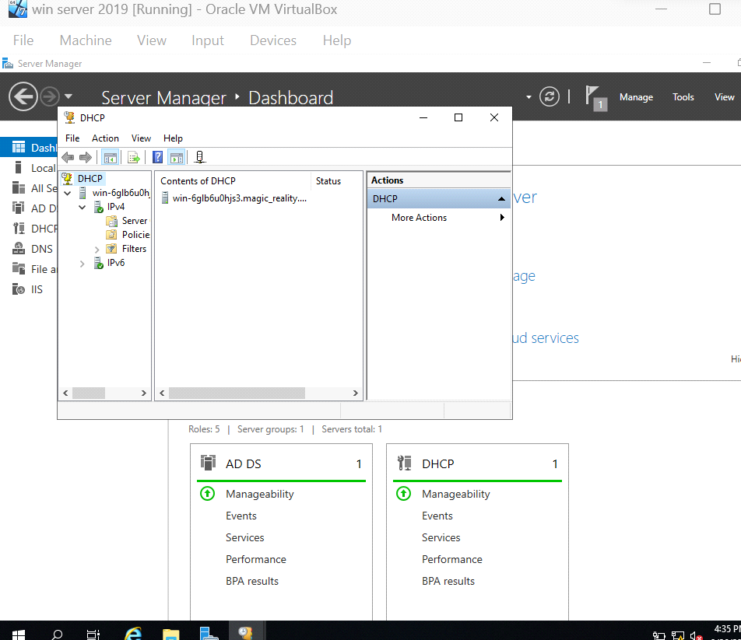

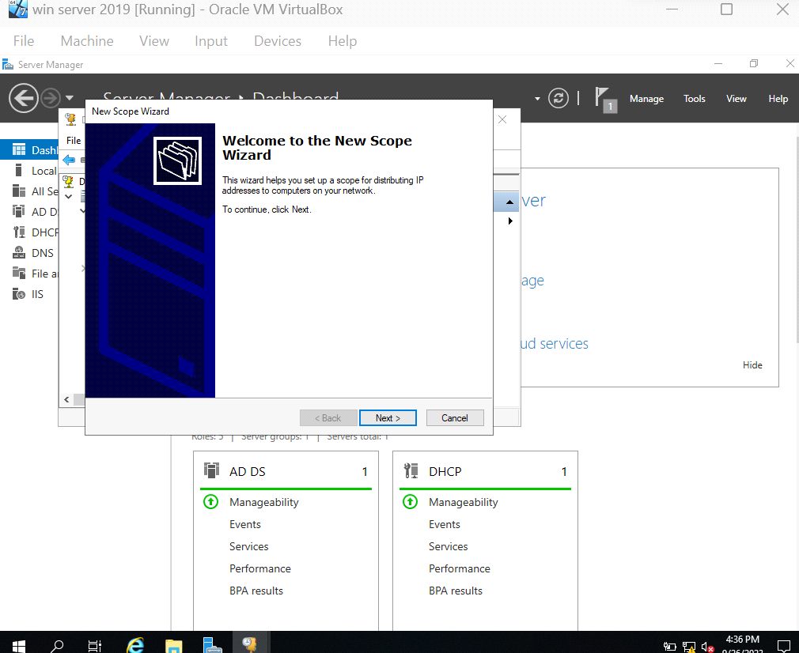

**Utilise the New Scope Wizard to**:

* Scope - Please provide a name and brief description.

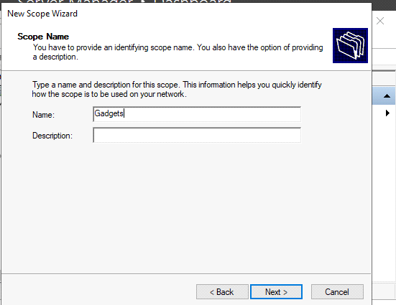

* Instruct the DHCP server what IP address range to use when assigning IP addresses to clients.

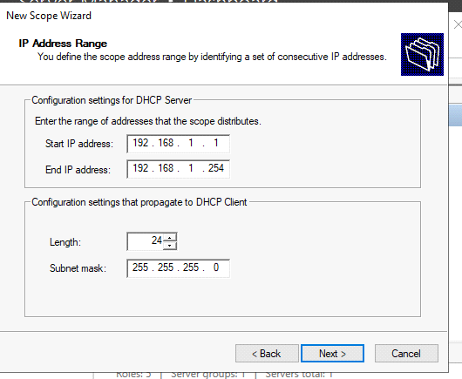

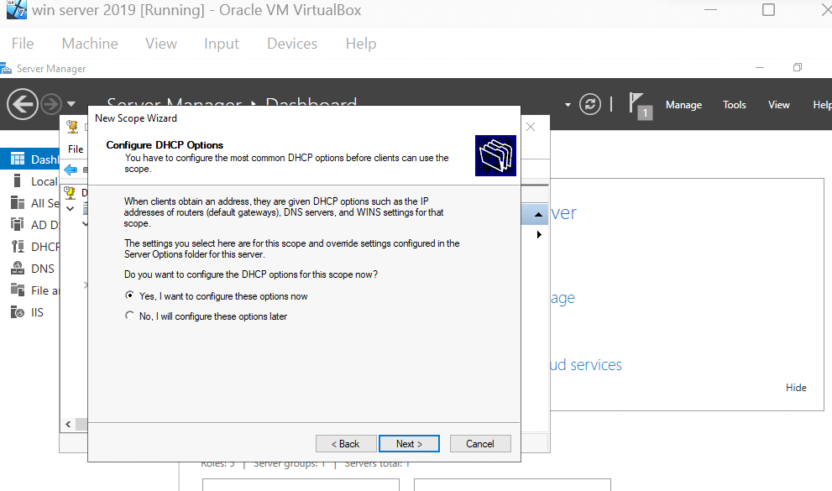

* Set the DNS server, default gateway, and subnet mask.

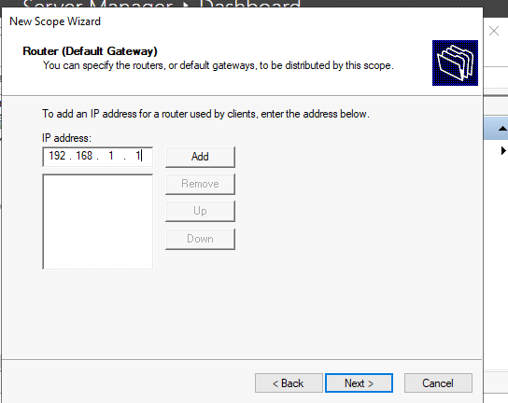

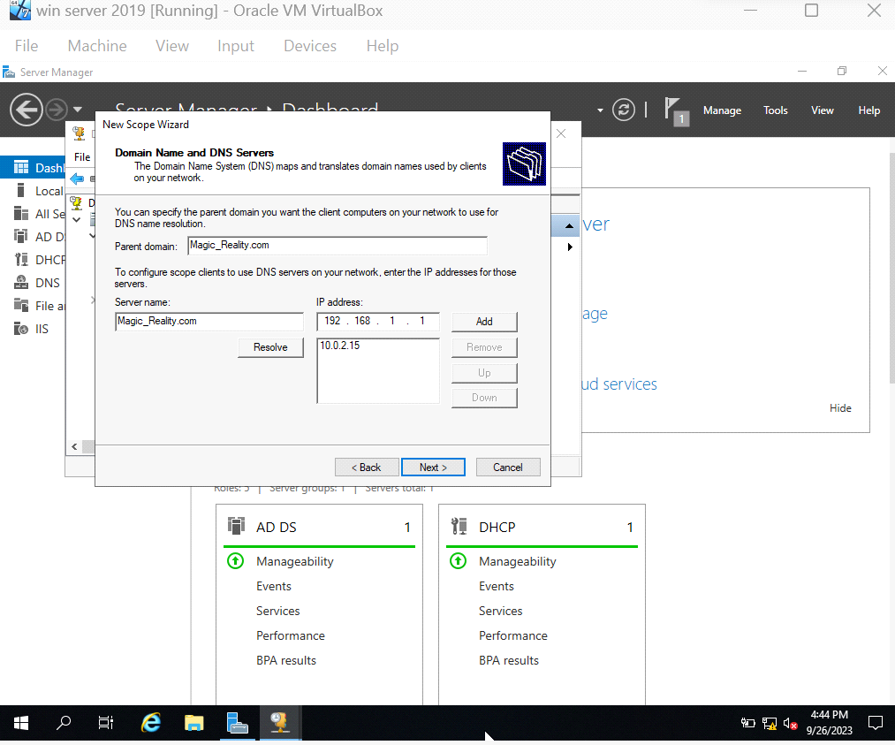

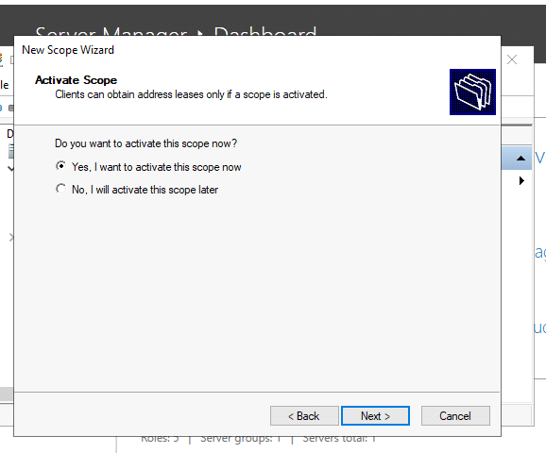

* Determine how long a customer has to utilise an IP address that has been allocated to them (the lease period).
* After reading and verifying your selections, click "Next" to continue with the process.

**Activate the Scope:**

* Check the summary of the setup and then click "Finish" to build the DHCP scope.
* Finalise DHCP Server Setup:
* Select "Next" to proceed with setting up the DHCP server.

Note: You should now be able to use your DHCP server to assign IP addresses to other computers on your network. Verify that your DHCP clients are set up to automatically receive an IP address (DHCP enabled) when they connect to a network.

**DHCP IP address reservations require these steps:**

* Use the DHCP server configuration interface.

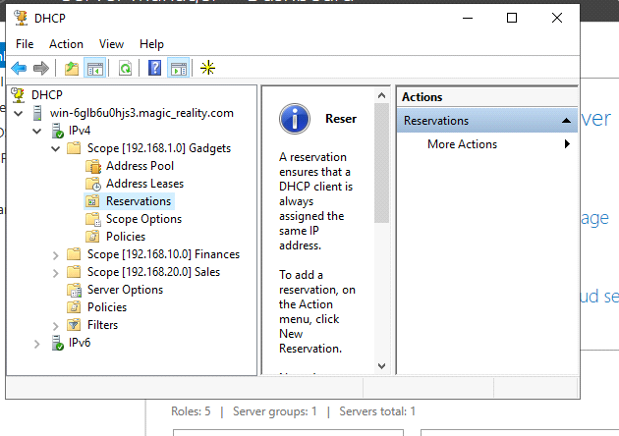

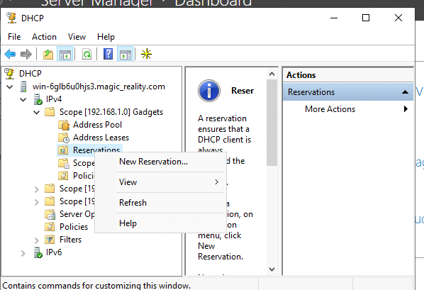

* Find the MAC address of the device you wish to reserve an IP address for.
* Enter DHCP reservation configuration.
* Enter the MAC and IP addresses to reserve.

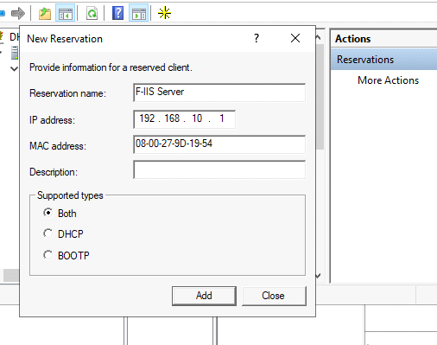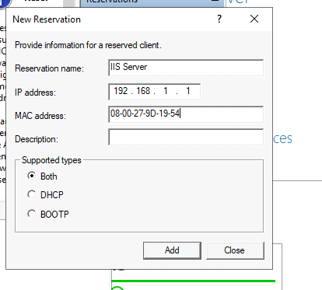

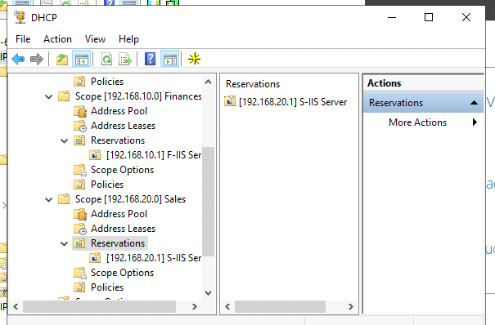

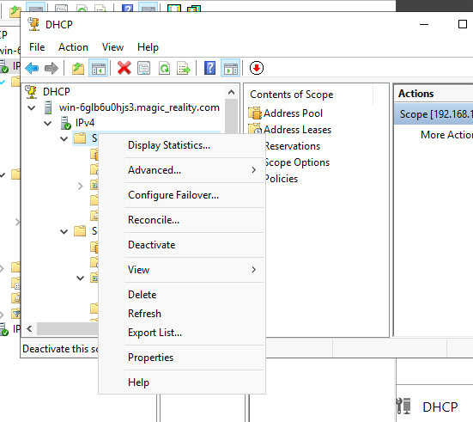

* Optional gadget name for easier identification.
* Save or apply settings changes.
* Restarting the reserved device or renewing its DHCP lease tests the reservation.
* Verify the DHCP server's lease table reservation.
* Make more reservations if needed.
* Keep track of DHCP reservations and update them as your network changes.
* These methods ensure that certain network devices receive the same IP addresses from the DHCP server, improving network management and stability [2].

# Instructions for creating an OU in Active Directory and assigning users, machines, and groups to it

* On a Windows Server, open "Active Directory Users and Computers" as an administrator.
* Make a new organisational unit inside the target domain.

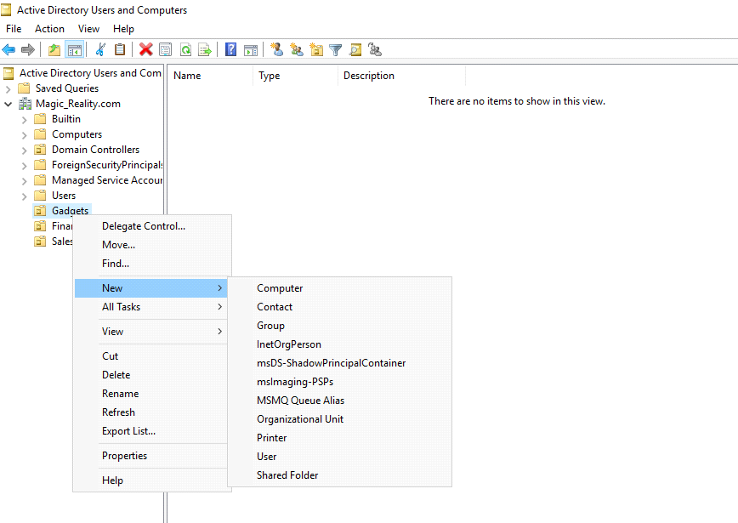

* Users can be added to the OU by right-clicking on it and selecting "Create User."

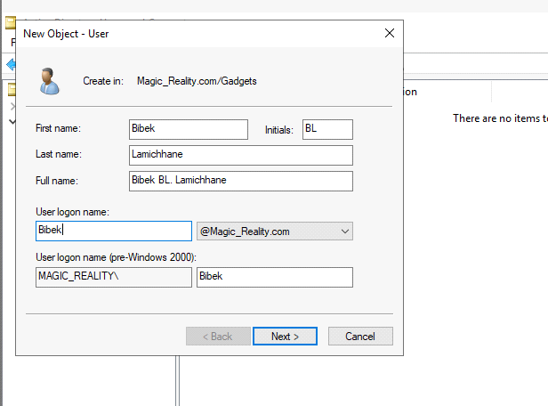

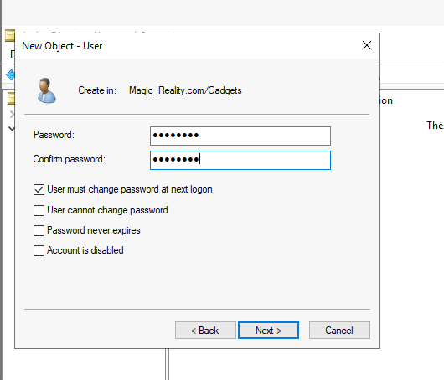

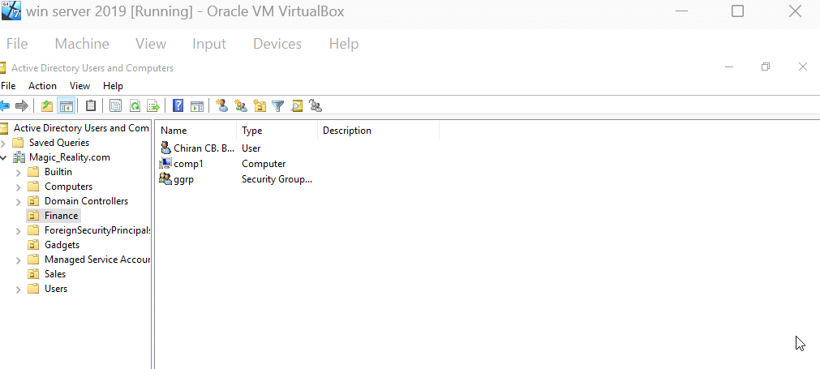

* Right-clicking the OU will allow you to add computers by making new accounts for them.
* Create a new group within the OU by right-clicking on it.
* Move, delete, or alter object properties to organise and manage resources inside the OU.
* Group Policies can be applied to the OU to make certain changes to settings and configurations mandatory.
* Check that the new users, machines, and groups are all properly functioning.
* Keep an eye on the OU and its contents and update them as needed to reflect any shifts in your organisation.

# To quickly connect a GPO to an OU in Active Directory

**You must take the following measures:**

* The Group Policy Management Console (GPMC) must first be activated.

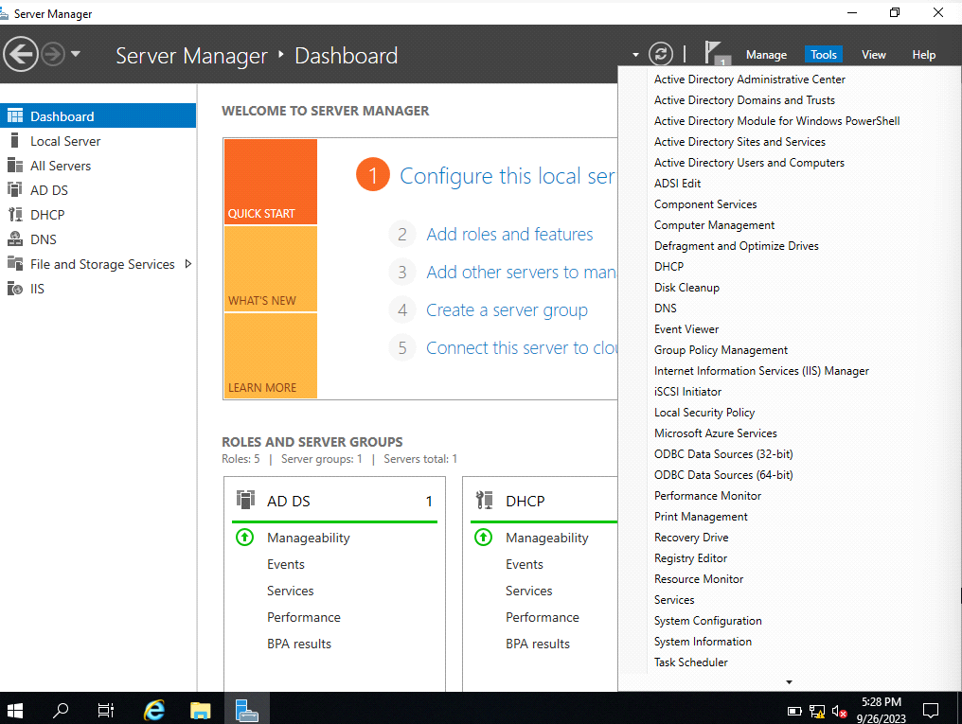

* To connect the GPO, head to the organisational unit you've chosen.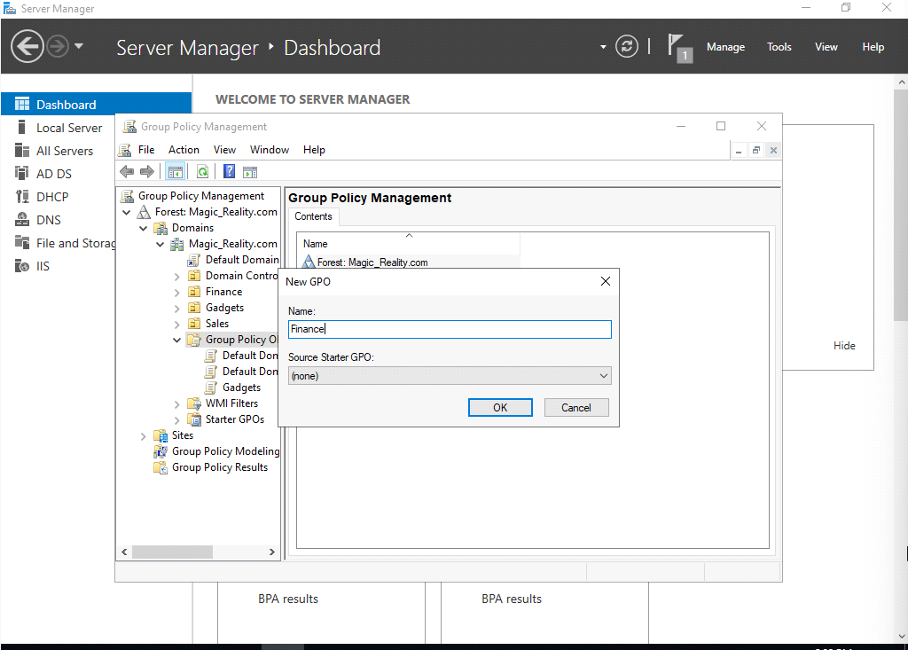

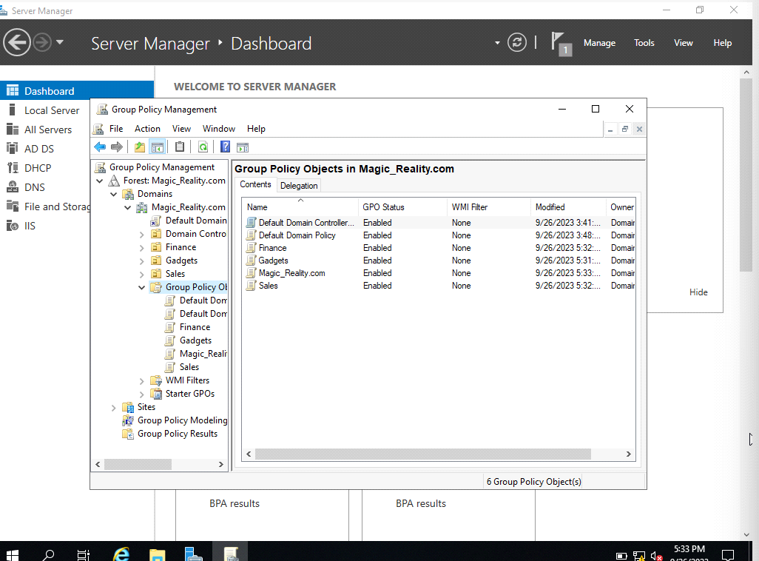

* Click the OU's right mouse button, and then select "Link an Existing GPO."

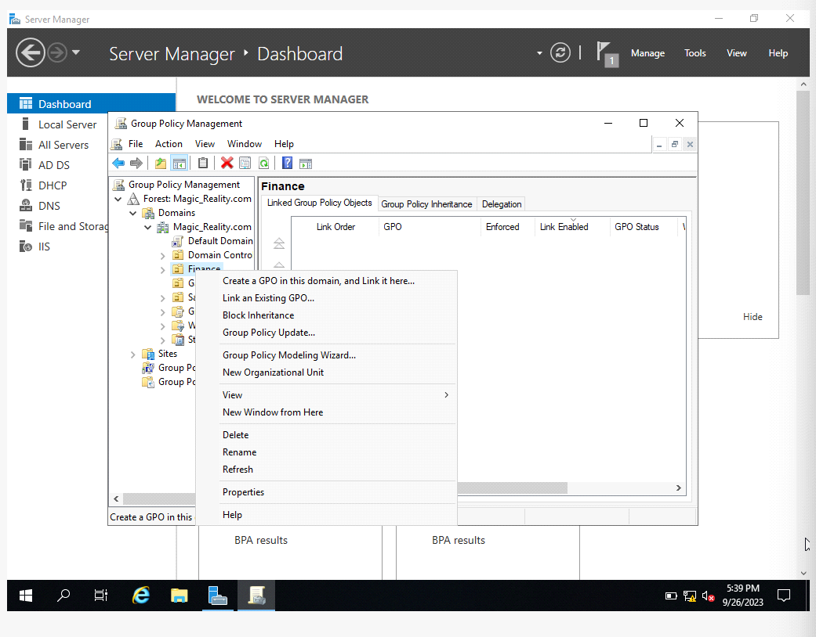

* Choose the Group Policy Object (GPO) you wish to associate.

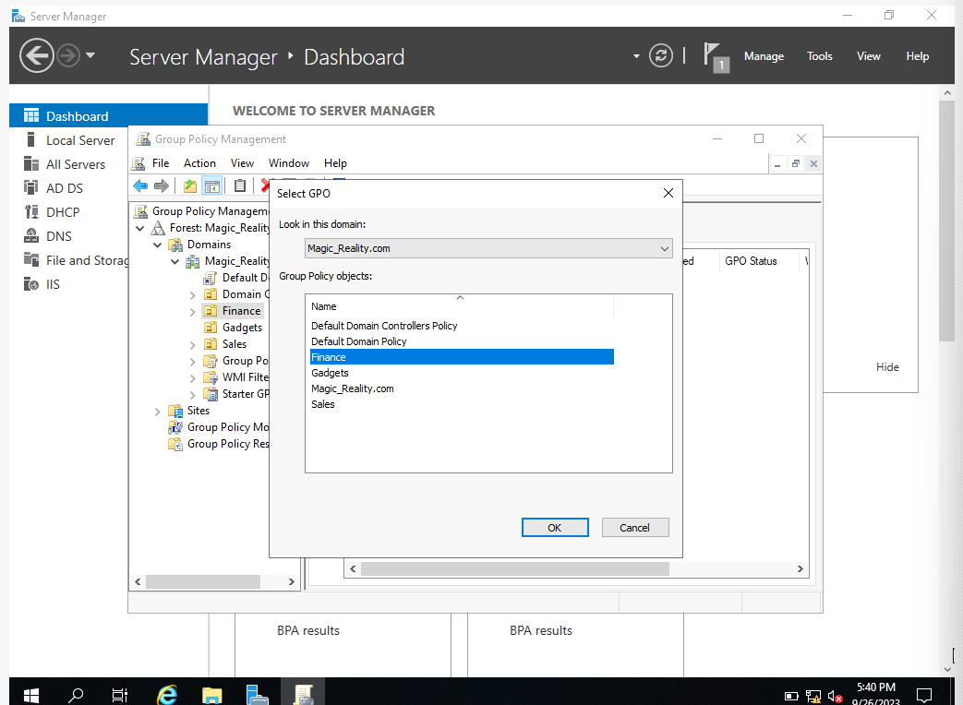

* When prompted, select "OK" to finish connecting the GPO to the OU.

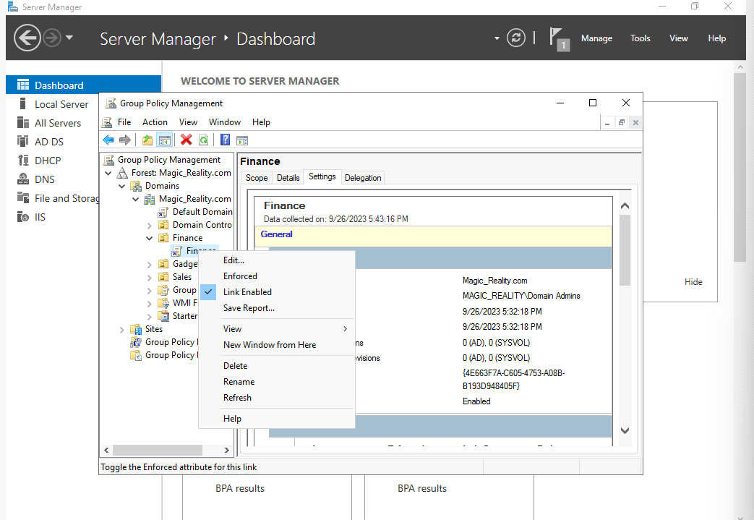

* Security filtering and WMI filtering can be set up for the GPO if necessary.
* The OU can now apply the GPO to its members (whether they be users or computers).
* To make additional changes to the GPO's configuration, right-click on it and select "Edit."

**Note**: It's important to properly manage GPOs and simulate their impacts in a test environment before releasing them to live systems [3].

# Privilege Assignment

**Setup Group Policy Objects:**

* Find the Group Policy Object (GPO) you wish to edit in the GPMC.
* You may edit the GPO by right-clicking on it and selecting "Edit."
* Policies can be tailored to your organization's needs by using the Group Policy Management Editor. Some instances are as follows:
* In "Computer Configuration" > "Policies" > "Windows Settings" > "Security Settings" > "Account Policies," you can set requirements for password complexity, length, and expiration.

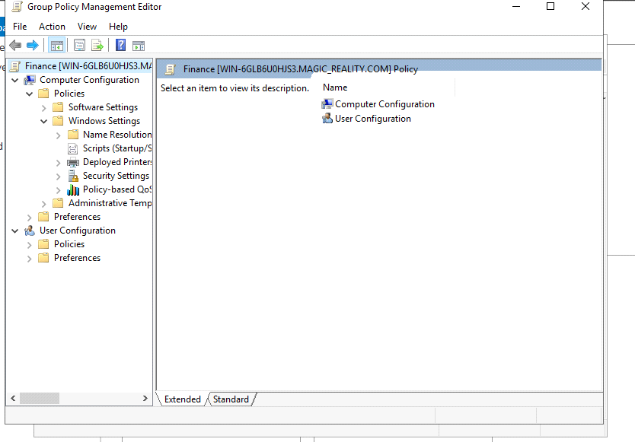

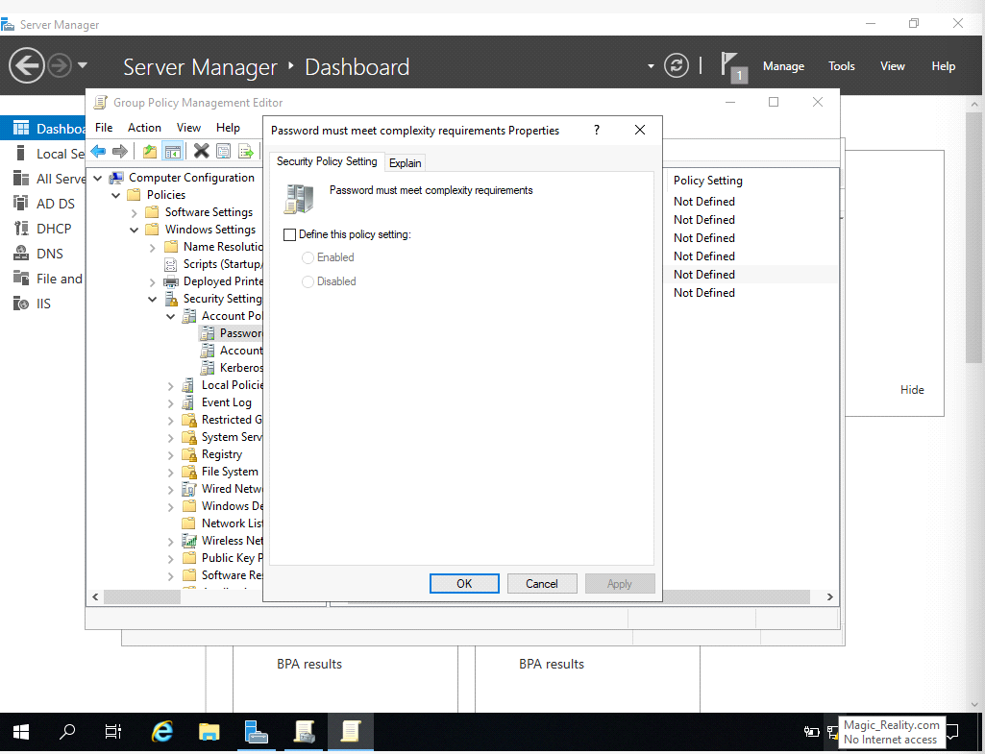

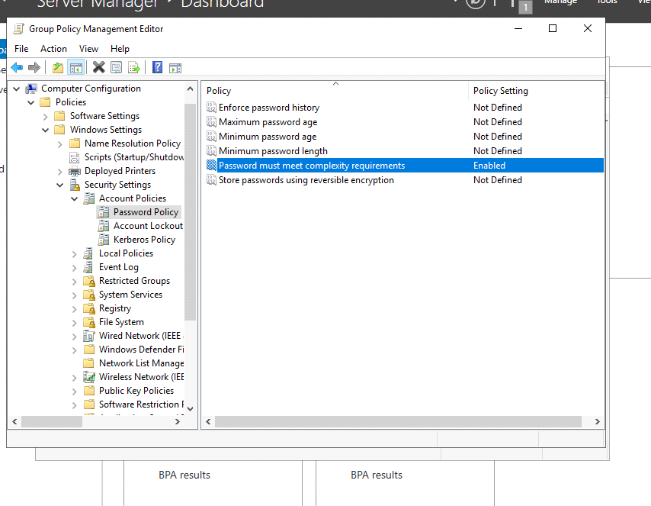

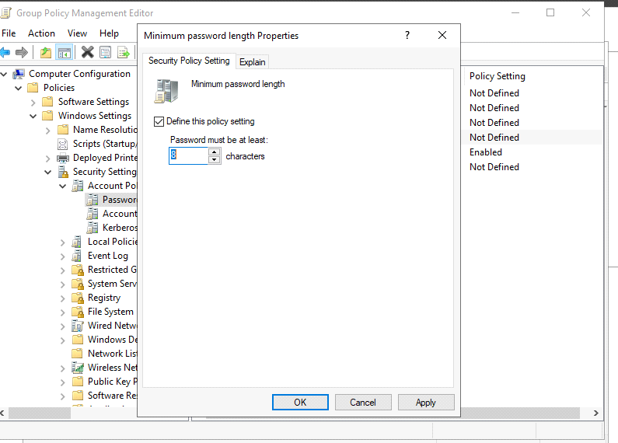

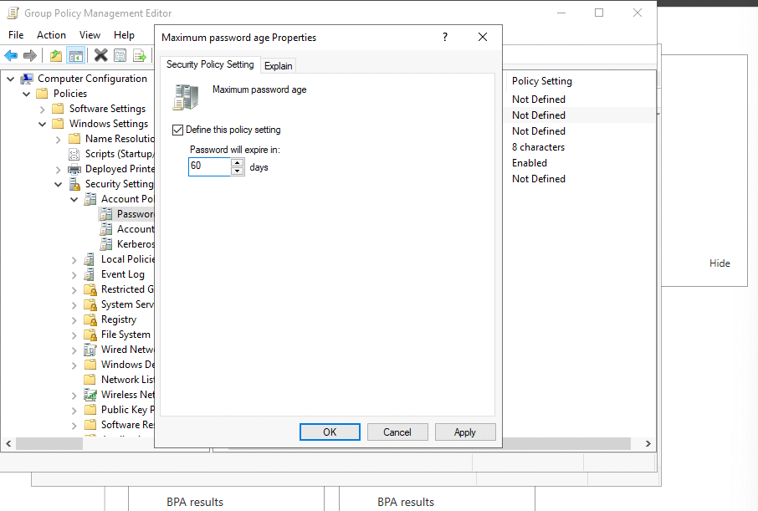

**Access Control:**

In "Computer Configuration," "Policies," "Windows Settings," and "Security Settings," set up access control policies such who can access what, how much authority each user has, and how often audits are performed.

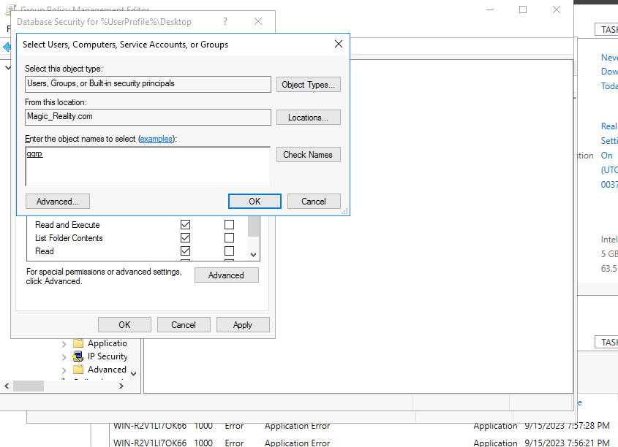

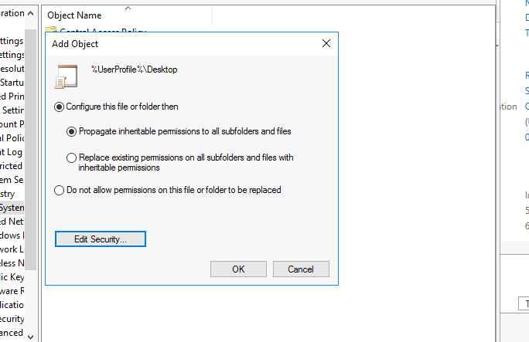

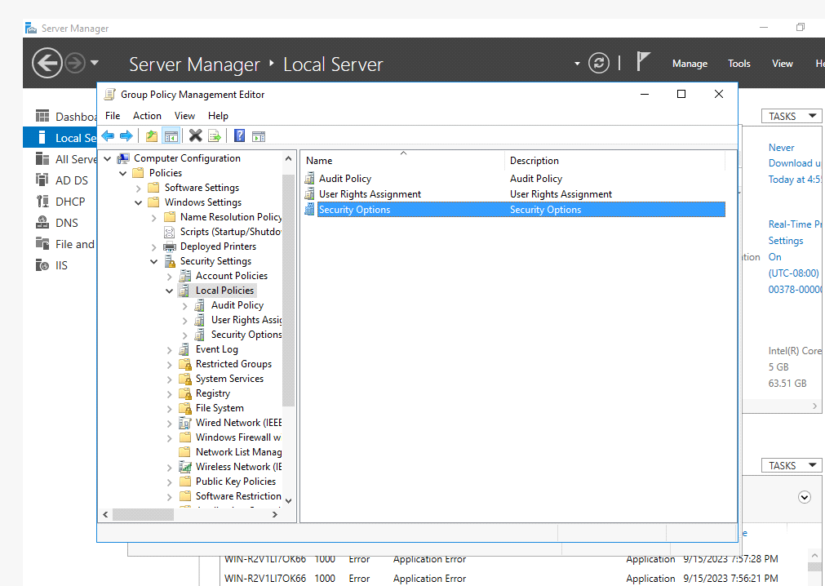

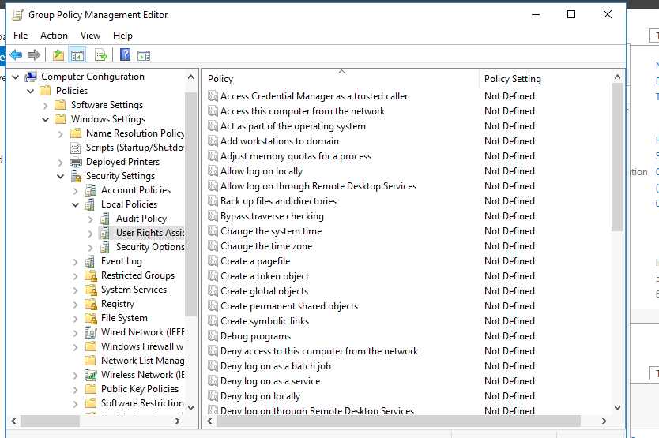

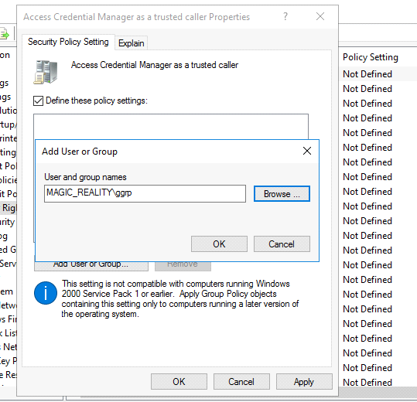

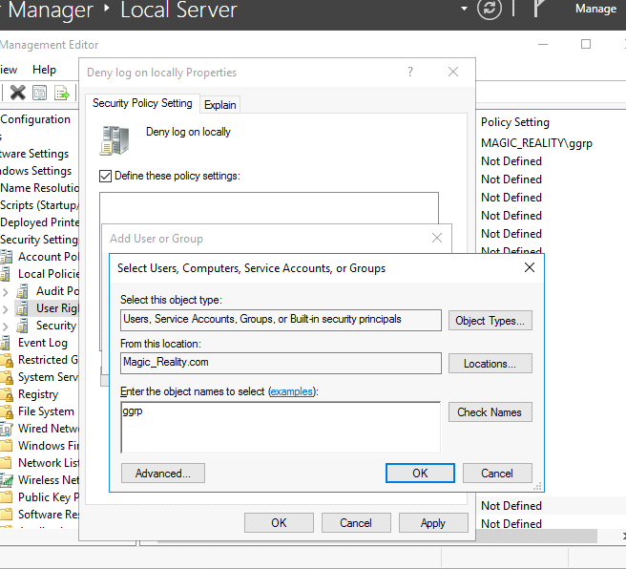



**Delegation Control:**

* Click "Active Directory Users and Computers" under "Tools."
* To enable advanced settings, choose view from the menu bar.
* Delegate authority by right-clicking the OU.(The Delegation of Authority Wizard dialogue box will now appear.)

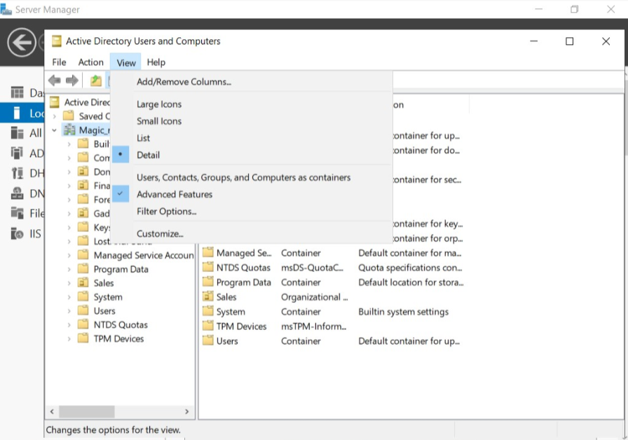

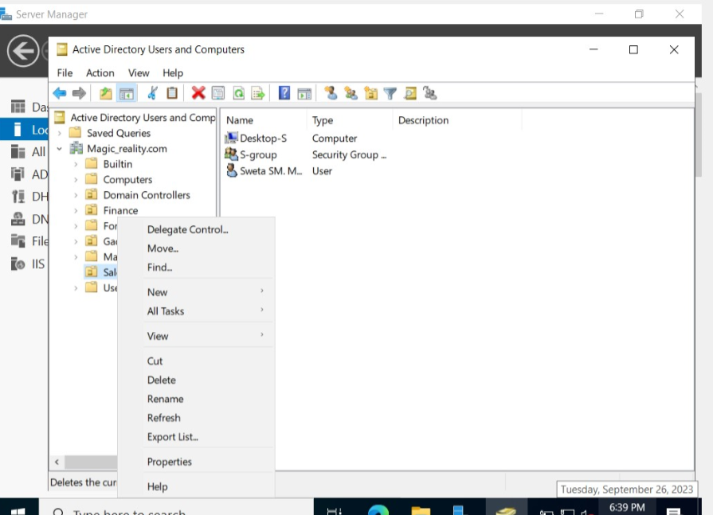

* Move on to the next slide.
* To add the chosen users to the group, click the Add button.
* When assigning tasks, it is customary to first verify the recipients' identities before moving on to selecting the tasks to assign.

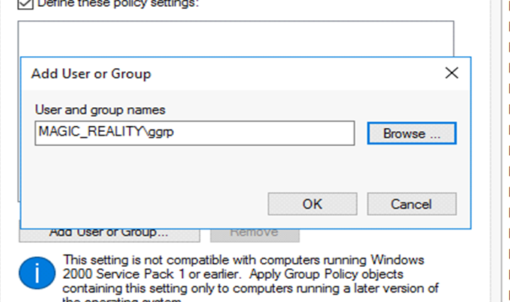

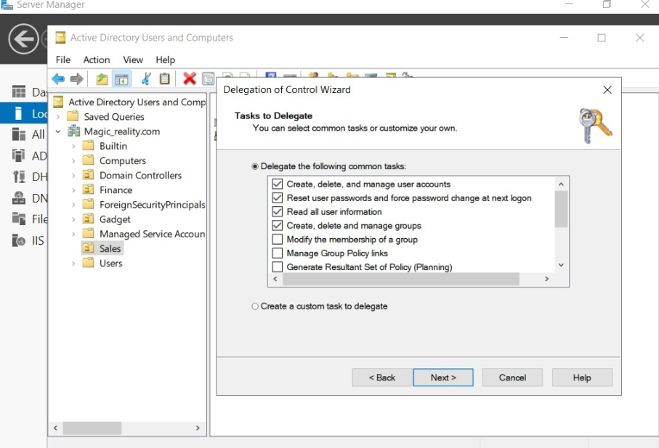

**Audit Policies:**

Follow the previous steps until security settings. And you have to expand it and can get audit policy options. Now, you can edit according the company’s desire.

**Note**: If you couldn’t find it go to Advances Audit policy configuration and edit according to the company’s needs [4].

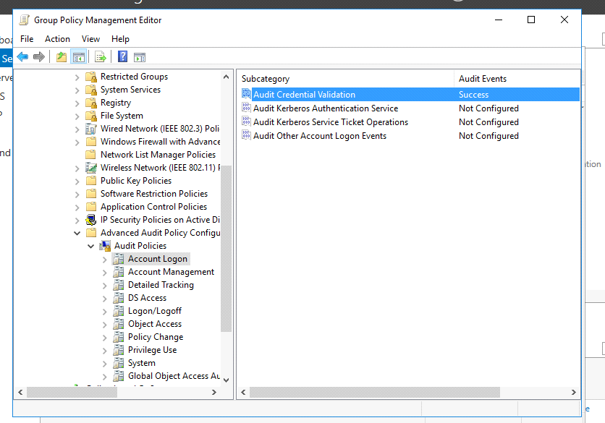

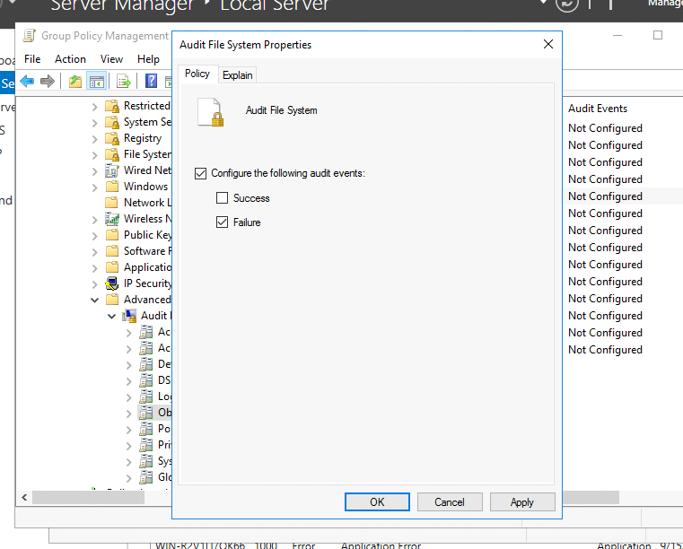

# The Setup of an IIS Server

* Select "Tools" > "IIS Manager"

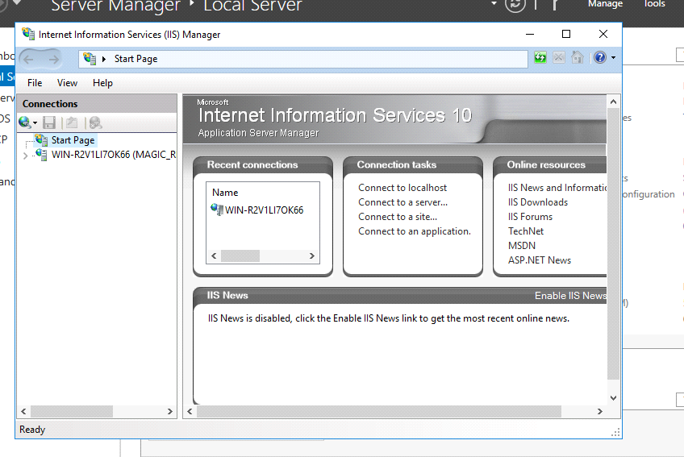

* Double-click to make your dreams come true.
* Try right-clicking on some websites.
* To add a new URL, select the corresponding button.

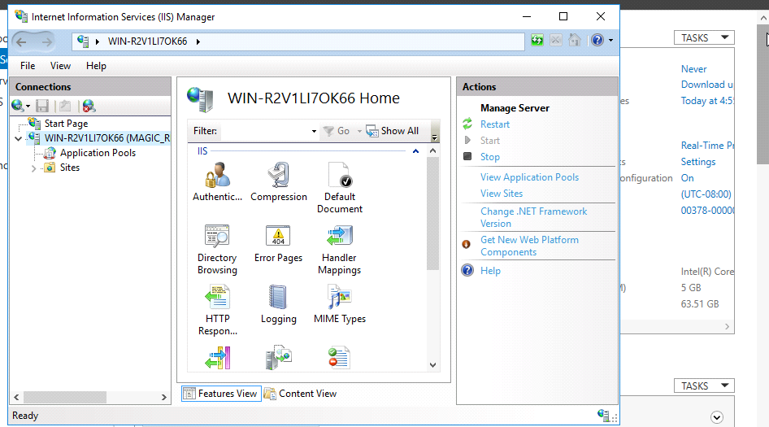

* Select system/inetpub/ wwwroot from the "add website" menu.

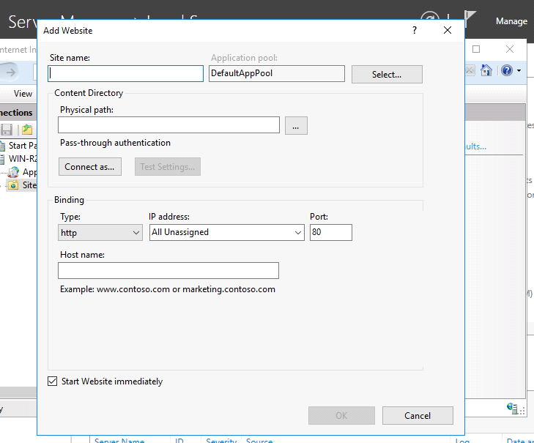

* Select "OK" to continue. (We're about to make a website using our own domain)
* A start and stop button for the managed website appears on the right.

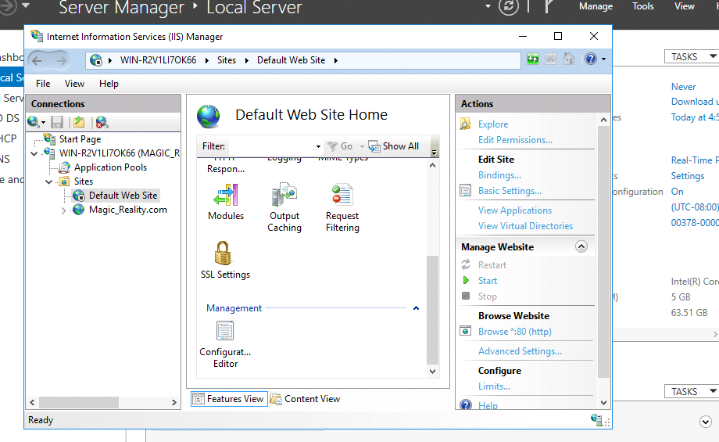

* Stop opening new tabs in your browser and open magic_reality.com instead.
* When you're ready to check out the hosted site, select the explore website option.

**Note**: Before exploring the website you have to set a website as a trusted one [5].

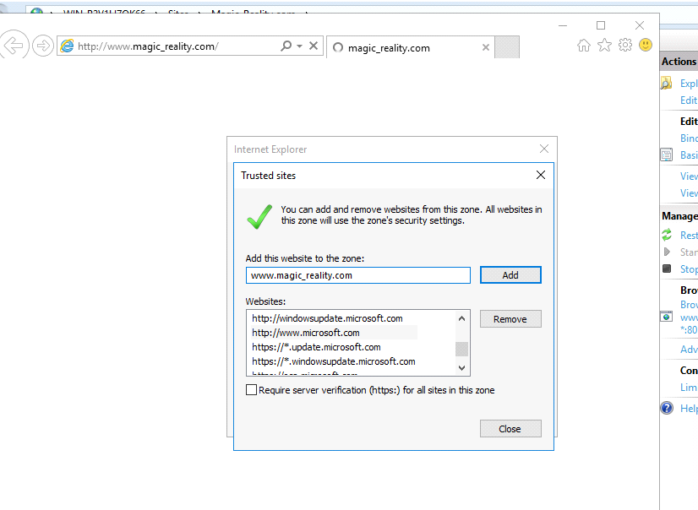

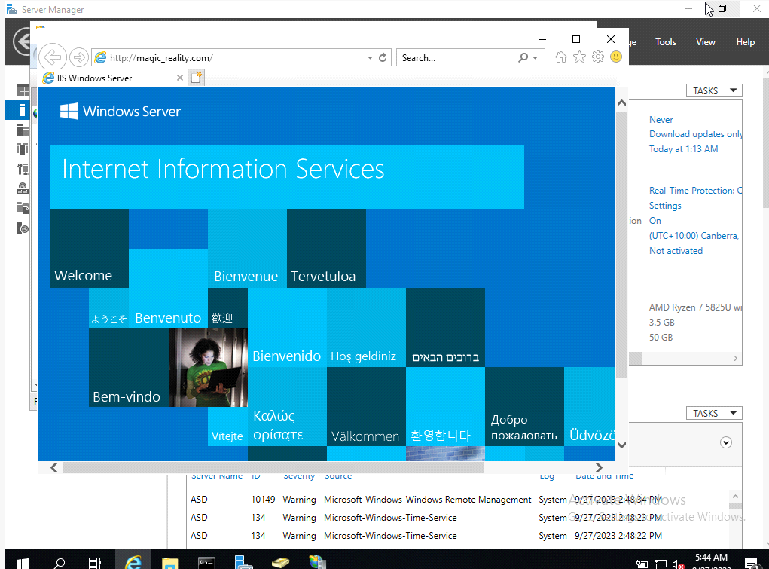

# Installation of child server

* Repeat the same steps we took with the parent domain's settings.
* After that add roles and features same as the previous parent domain and install it and complete post deployment configuration as shown in the screenshot below.
* Choose add a new domain to an existing forest and the domain name need just be updated to read "Melb-group." as shown in the screenshot provided below [1].

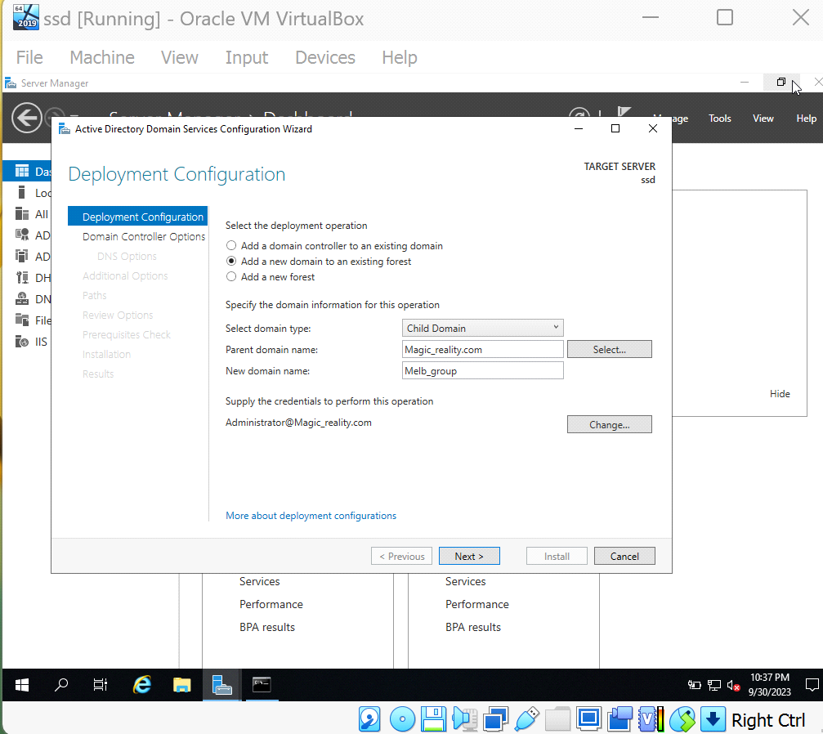

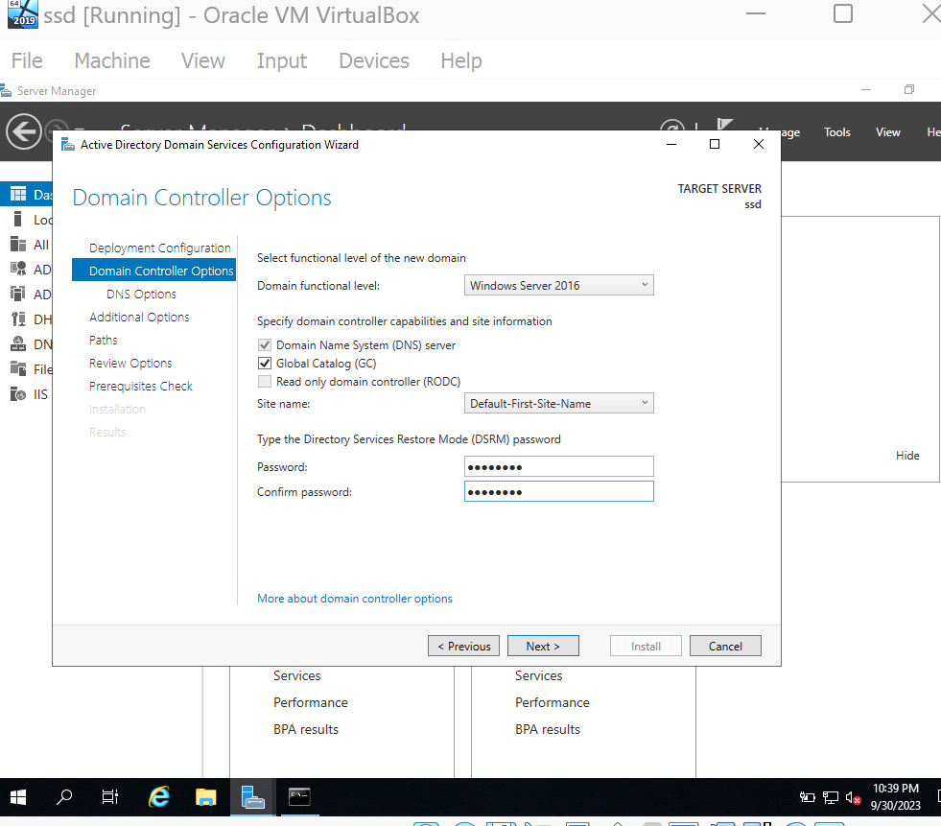

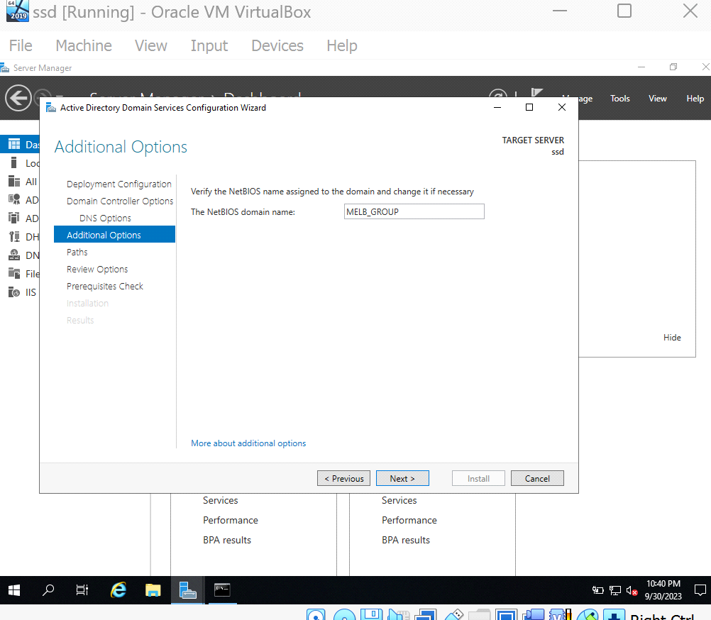s

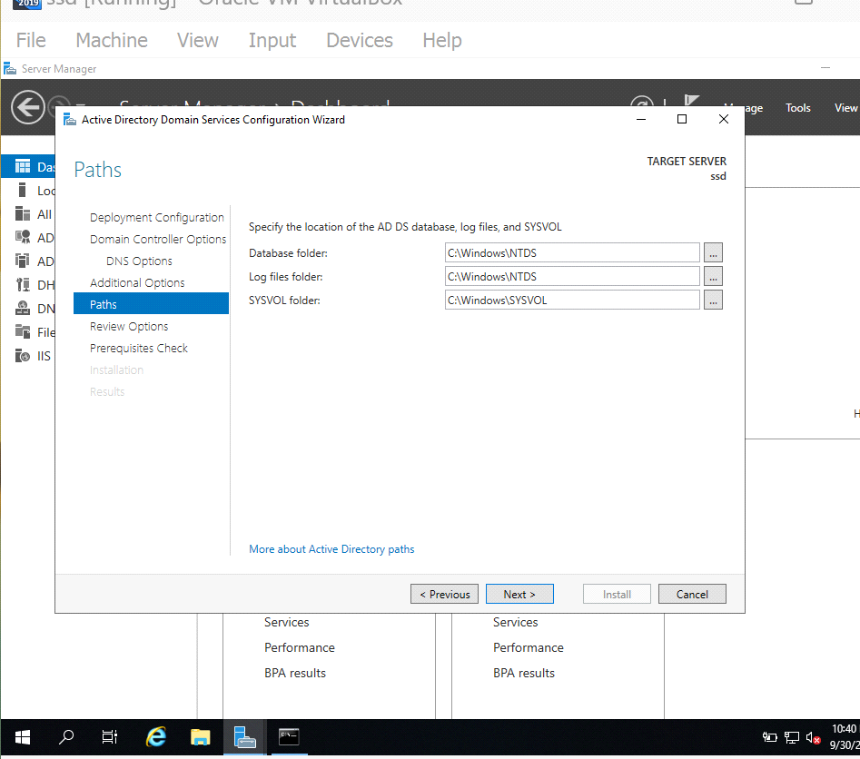

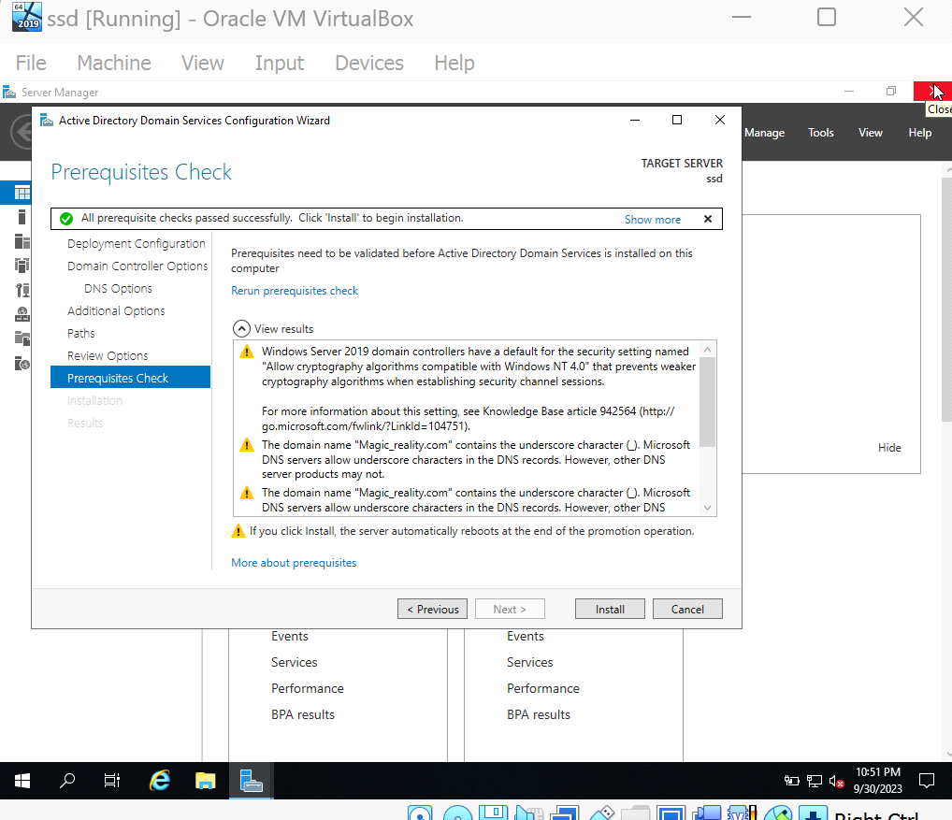

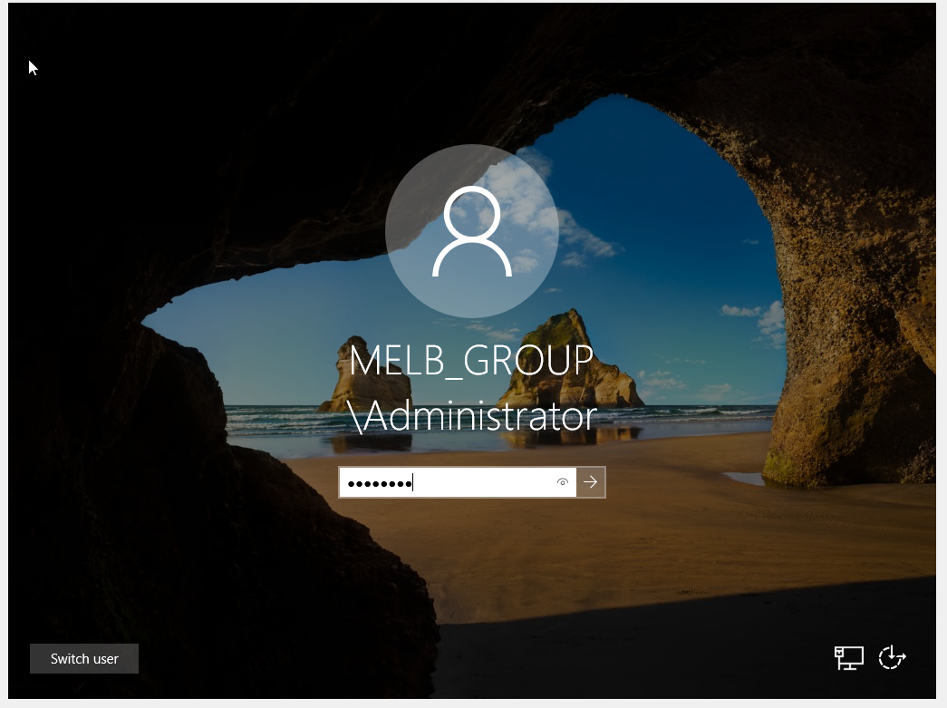

# Configuration on child server(Ethernet)

* Follow the steps same as we did on parent server

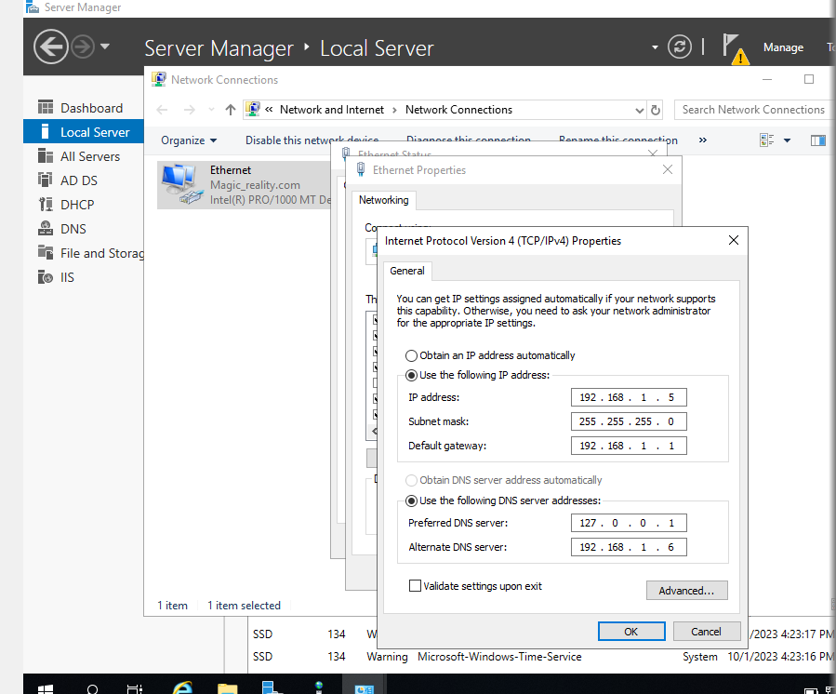

# FOR RELIABILITY AMONG SERVERS

To access Active Directory, click on Tools. Domains and Trust Right-click on magic_reality.com, select properties, and then click trust. Next, click the new trust box to bring up a wizard where you may enter the DNS or NetBIOS name of a domain you want to trust.

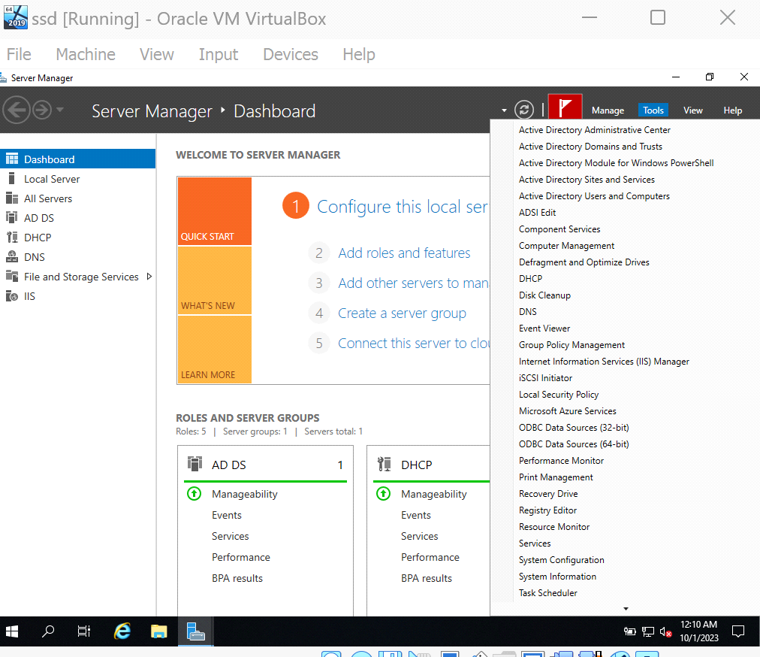

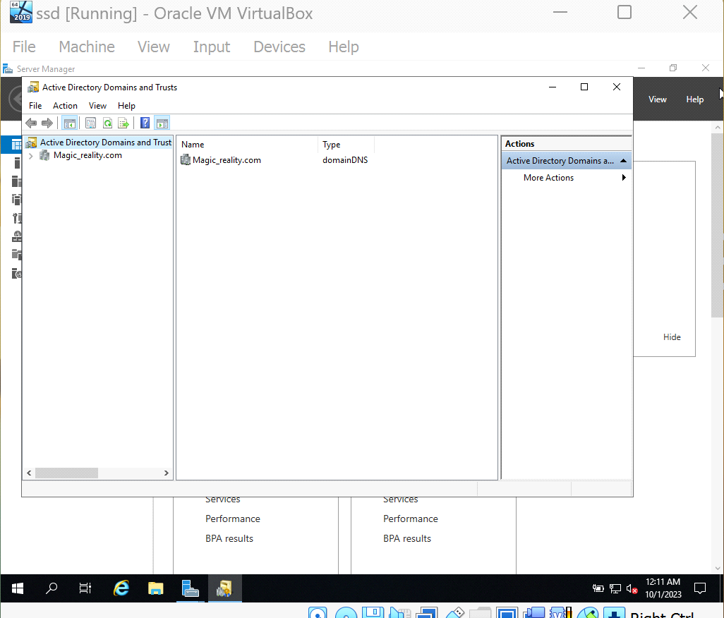

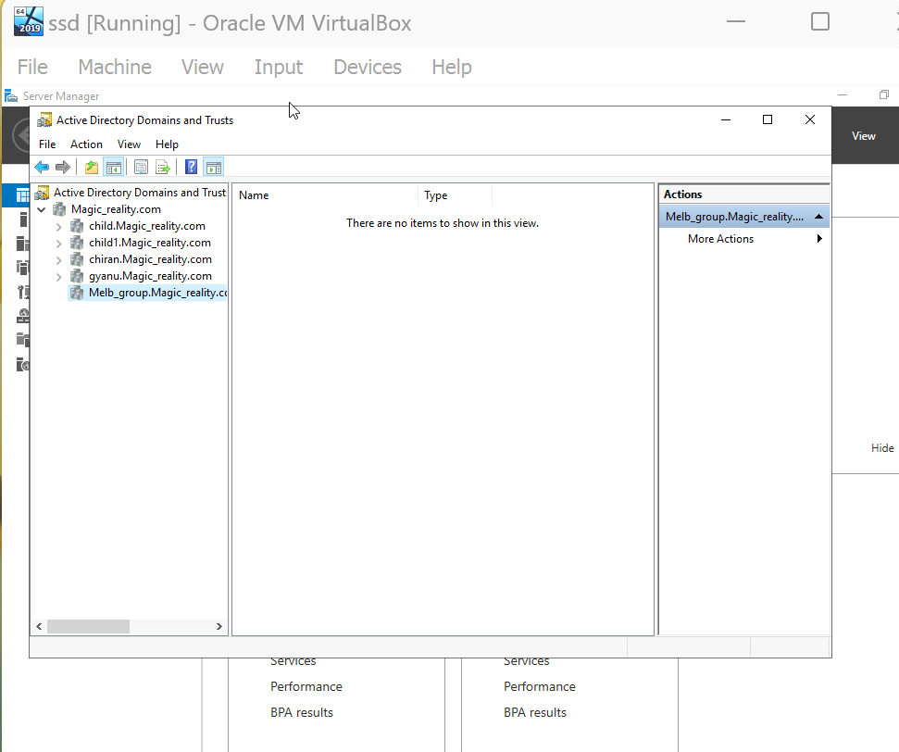

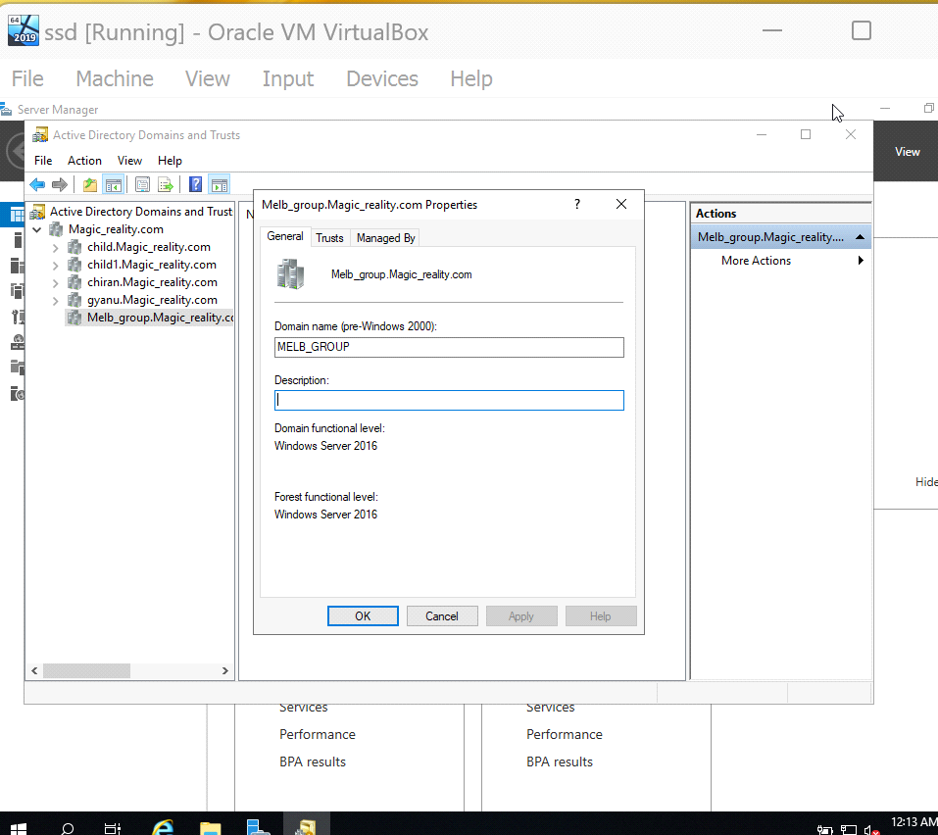

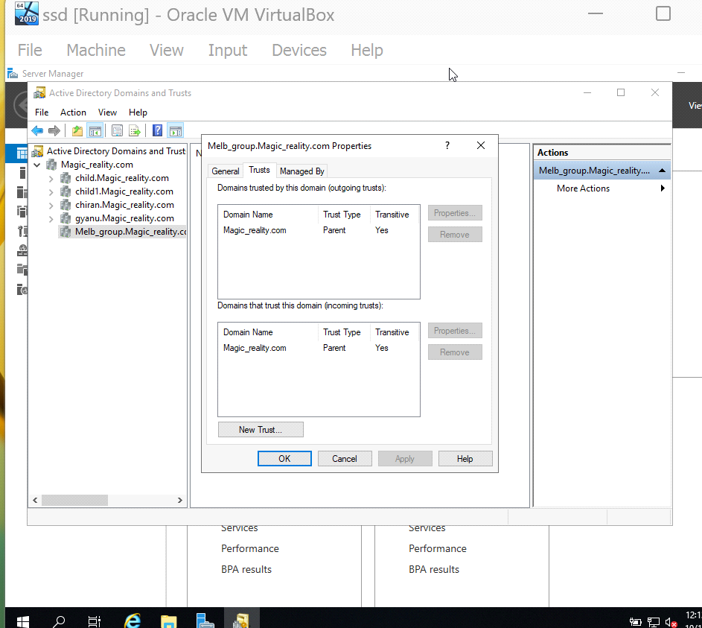

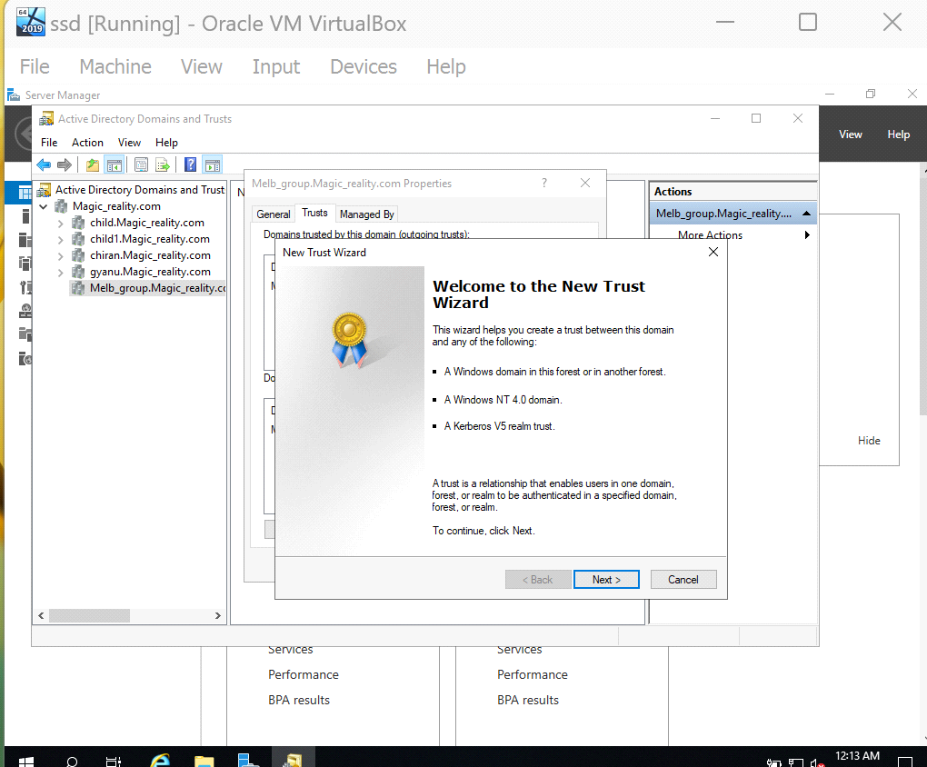

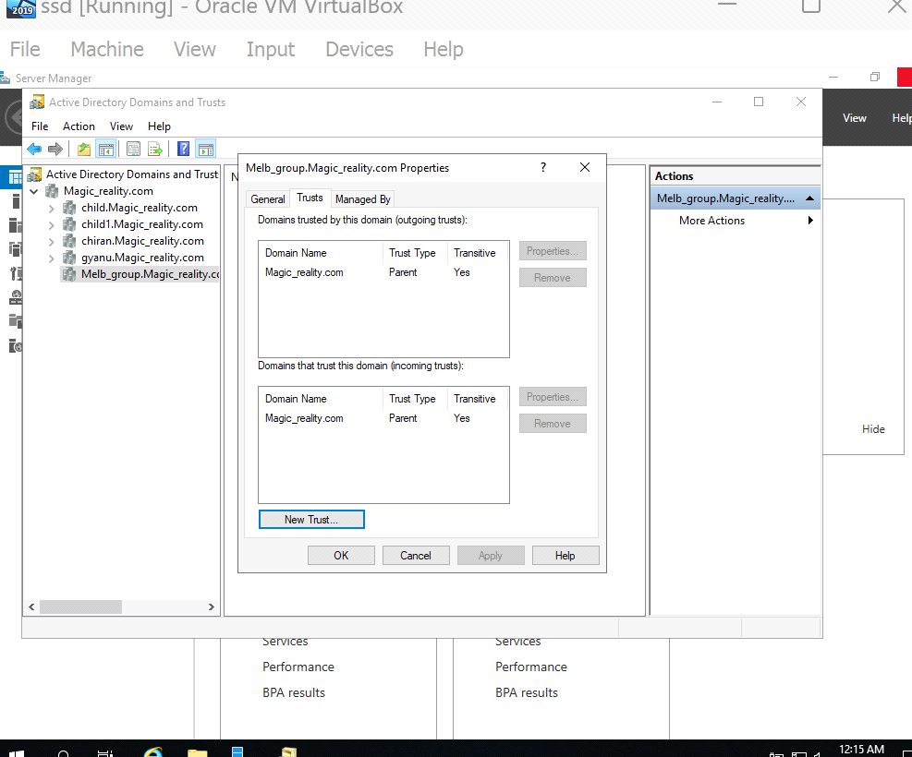

# Make sure the Child Domain has an Active Directory Integrated Zone:

* Connect to the child domain's new domain controller.
* Switch on the DNS Manager:
* To access the "DNS" menu, hit Win+X.
* Extend the server node in DNS Manager, right-click "Forwards Lookup Zones," and pick "New Zone."
* Give the wizard permission to make the zone and fill it with records.

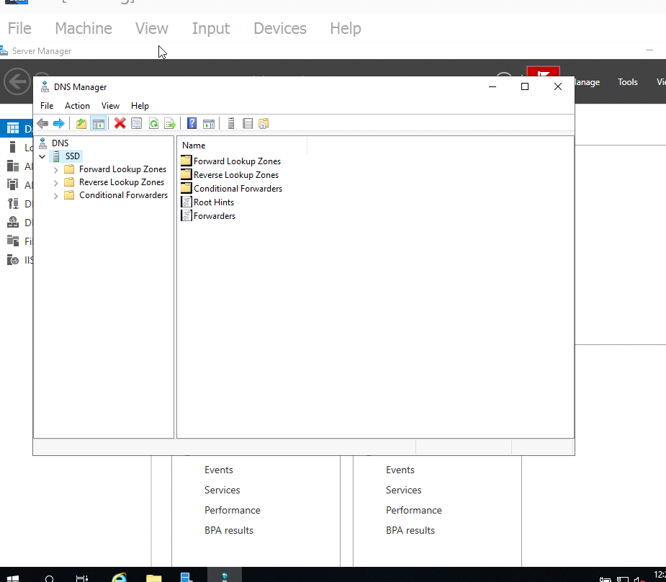

* Create an Active Directory-integrated zone by using the New Zone Wizard. To create a child domain, select "primary zone" and then enter the desired name (such as "child.magic_reality.com").

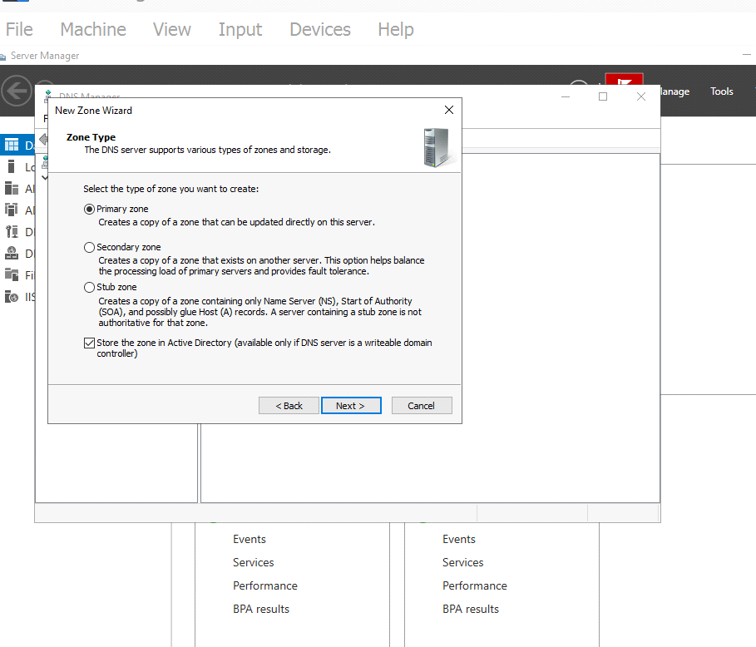

* Give the wizard permission to make the zone and fill it with records.

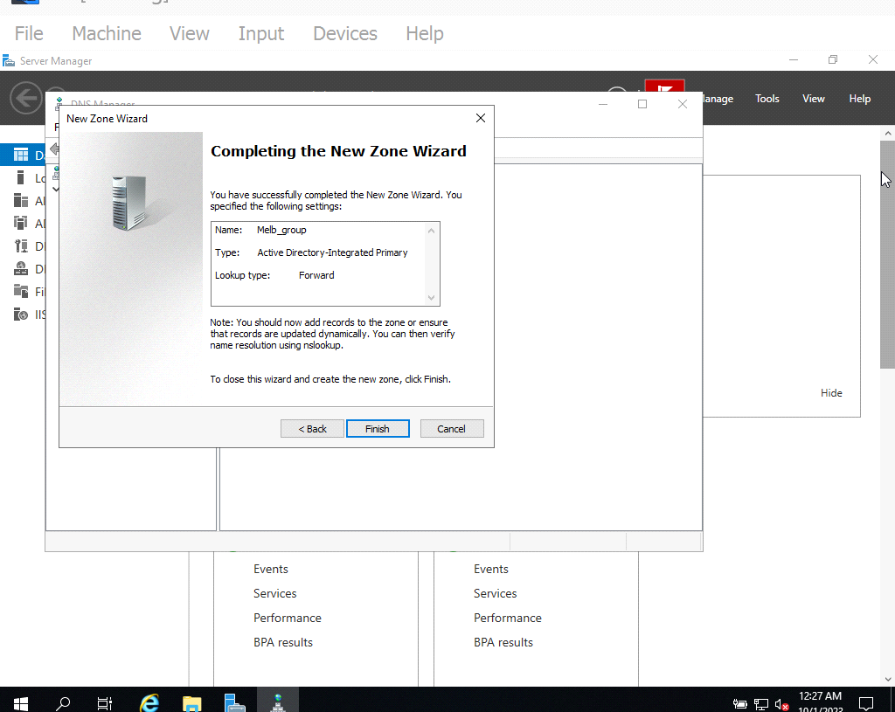

# Configure Forwarding DNS Record

* Right-click the server node in the DNS Manager and select "Properties."
* Click "Edit" within the "DNS domain" area.
* Click "OK" to save the modifications.

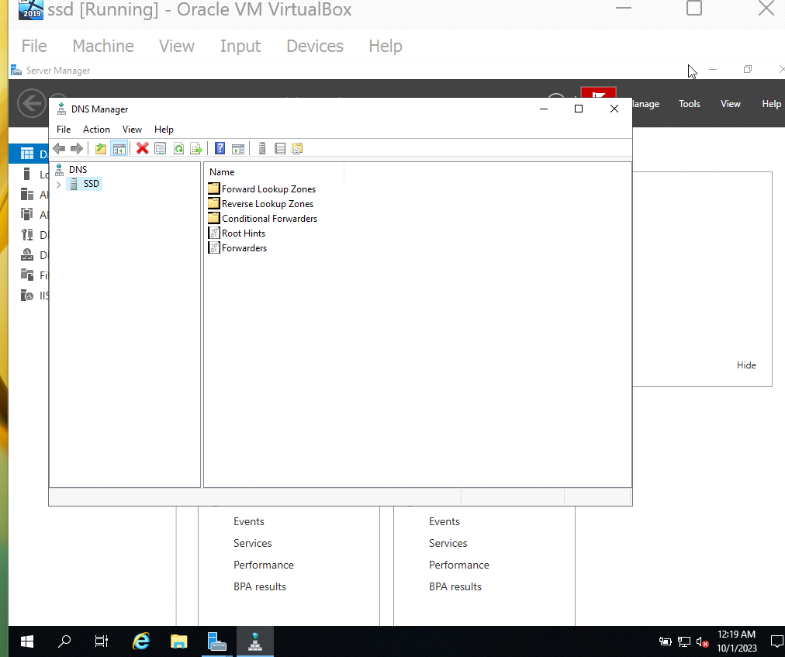

* To access the "Forwarders" tab, click here.

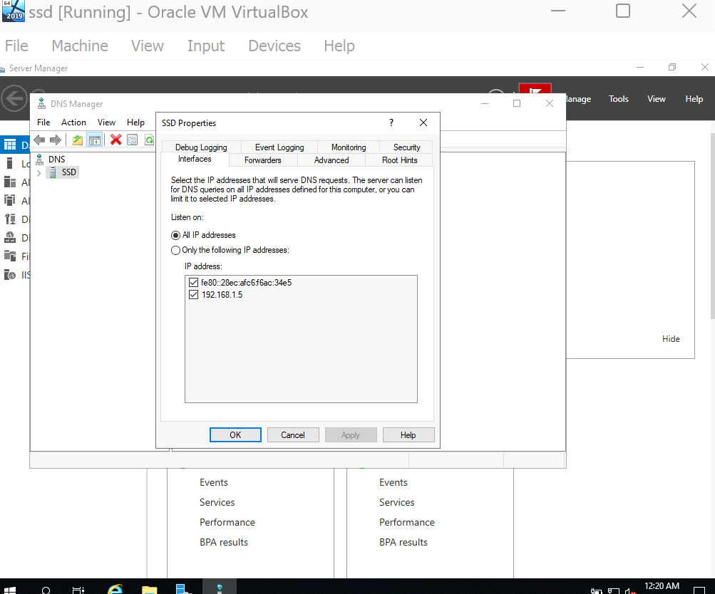

* Add the DNS servers for the principal domain (magic_reality.com) to the list of forwarders.

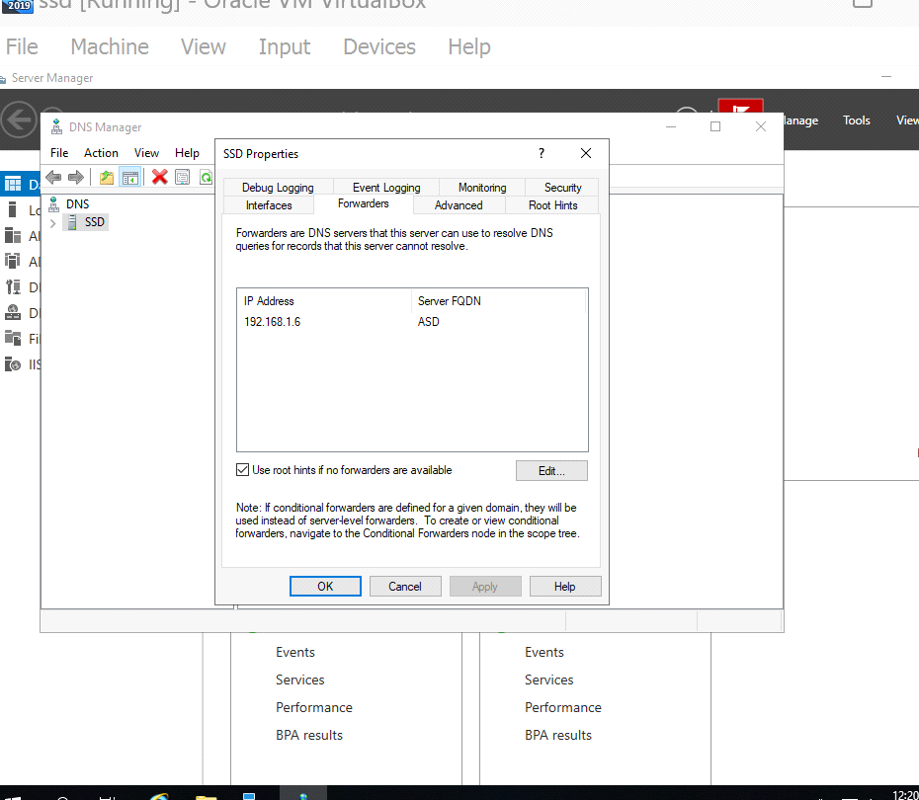

* Click "OK" to save the modifications.

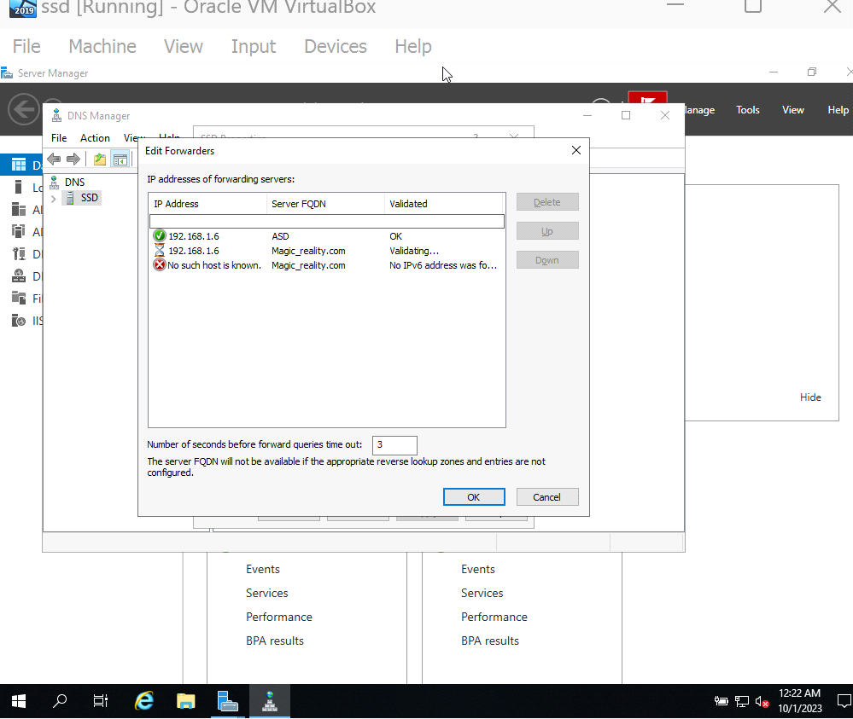

**Reverse Lookup Zone:**

* Launch DNS Manager in Windows Server.
* Create a new zone for reverse lookups.

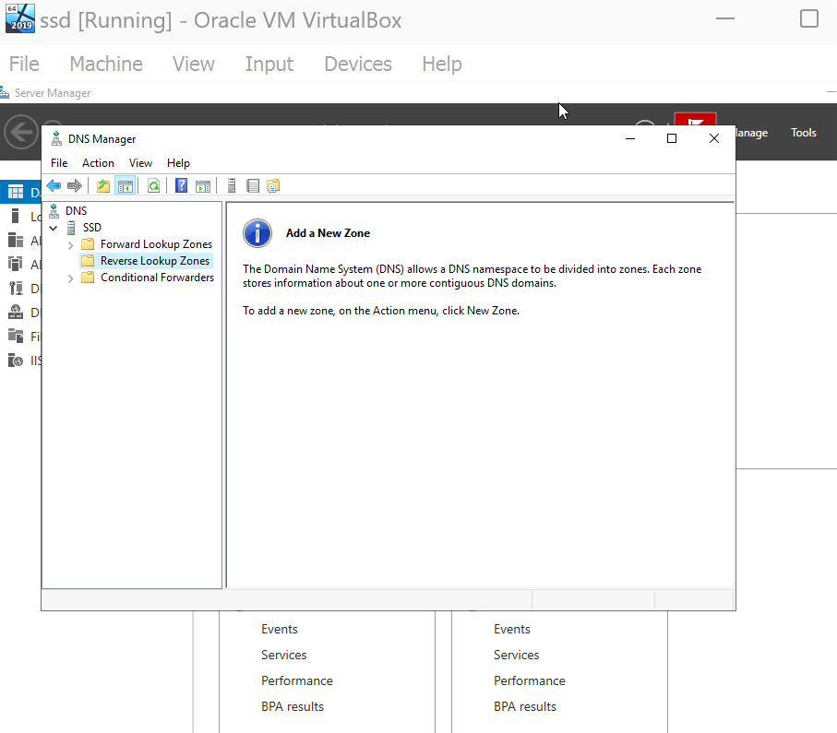

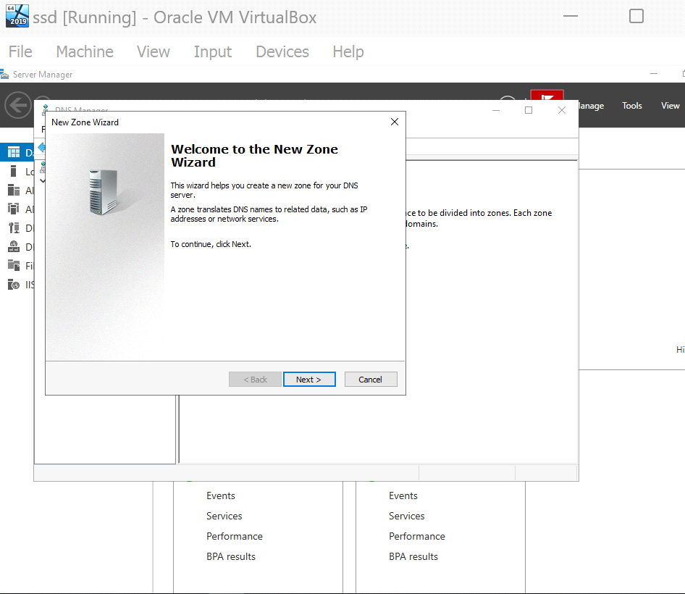

* Select primary Zone and put the host DNS name and complete the process by clicking the finish button.

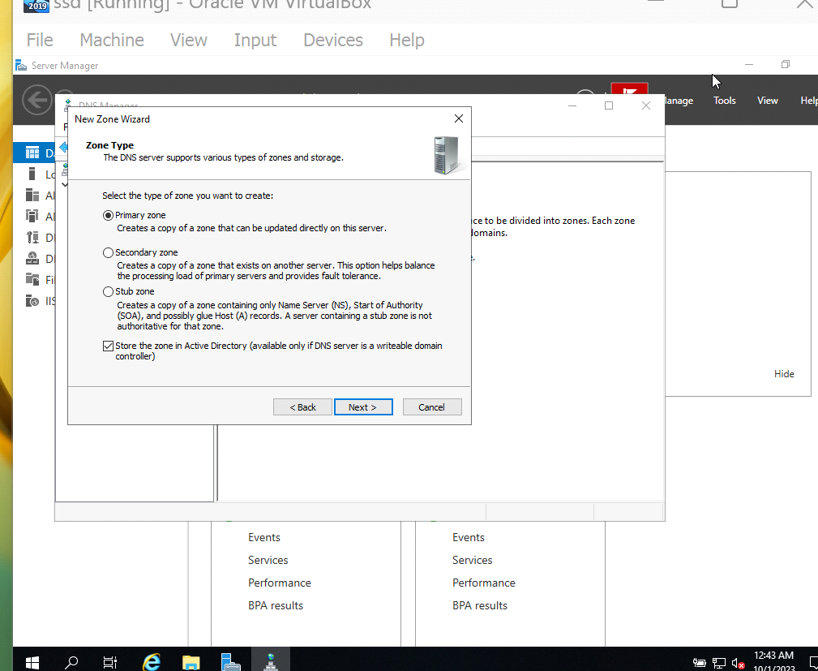

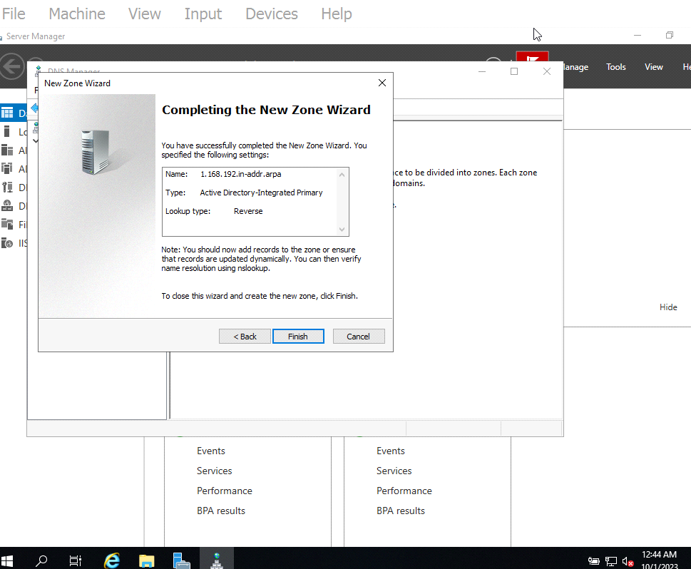

# Delegate the DNS sub domain on the parent domain

For example we created a test as organizational unit.

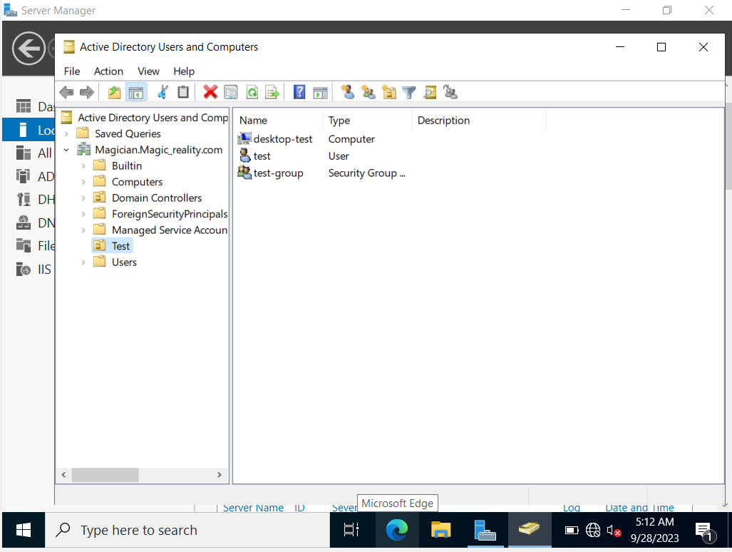

* Below is an example of how using the user's credentials that we generated previously in the parent domain can result in a login denial.

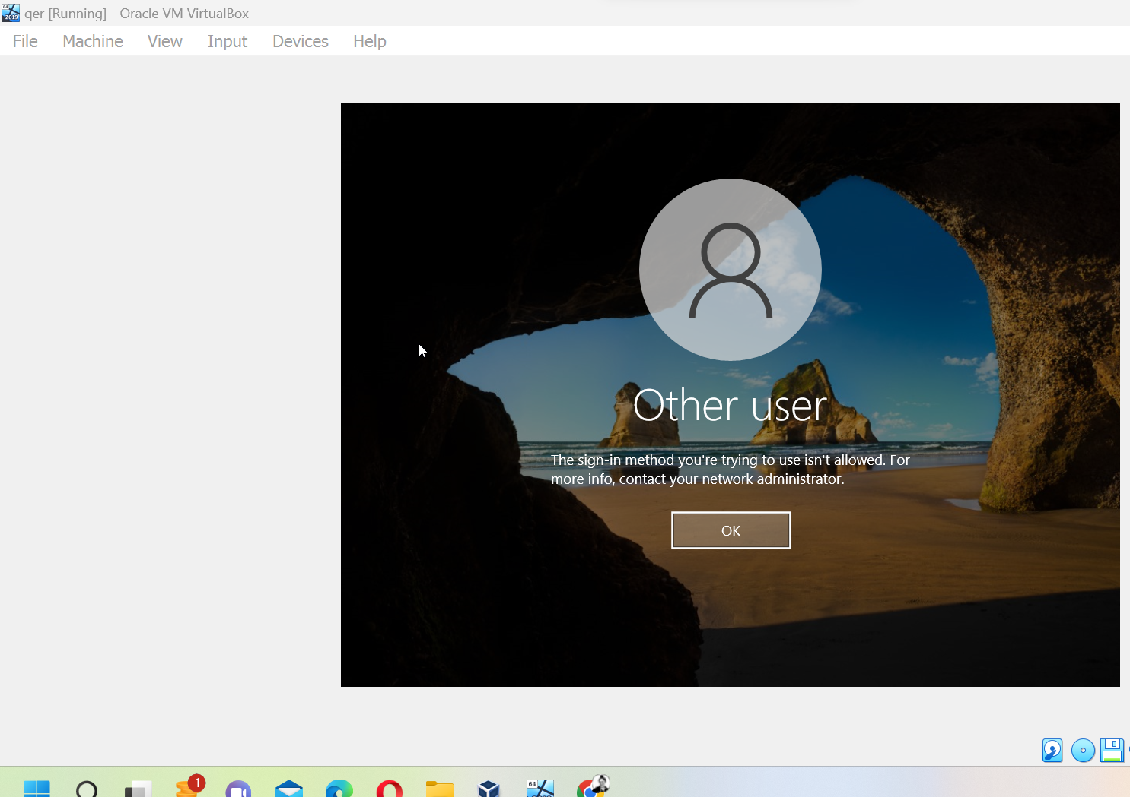

**New domain controller has access to test.com subdomain with delegated DNS.**

Procedures that are carried out:

* In the child server (magician), create a test.com subdirectory.
* Access the kid server's Active Directory users and computers.
* Start by right-clicking a folder, then typing "test.com," to bring up the context menu.
* To open the dialogue box, choose properties.
* Then, choose Share, add the people who should have access, and click Share.
* If the user is situated on the parent server, you may add them in Find People, but you'll need to edit their location.
* In order to access the parent domain and add users, you may be prompted to provide your credentials there.
* After signing in, you'll be able to choose the parent domain's location and begin adding users.
* Then, go to Computers and Users in Active Directory.
* Use the group's right-click context menu to access its settings.
* (A pop-up menu will show up)
* To access the members, please click here.
* Once again, set the hostname to the parent domain, magic_reality.com, as accounts are generated there.
* Join in!
* It's time to hit the "ok" button and "apply" button.(The new users now have full access to the shared folder.
* Windows users should then use the command childtest.com after logging in. Below is an example of how the folders could look on your screen.

Please take note that in certain circumstances file sharing is disabled during network discovery access to the shared folder. Thus, activation is required prior to folder access [6].

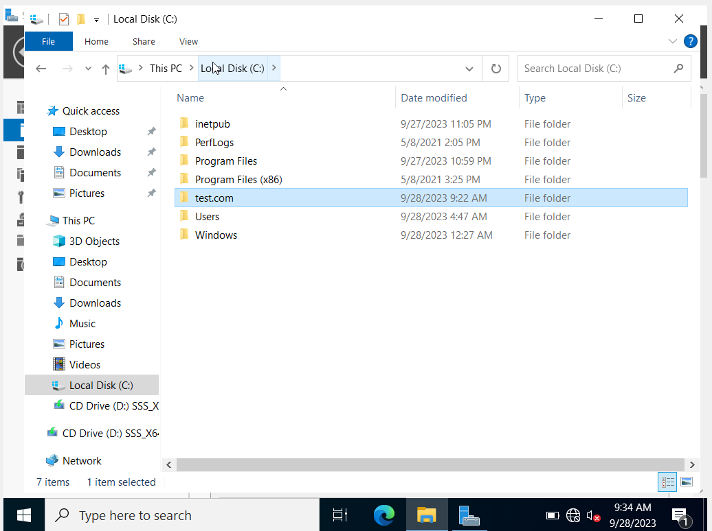

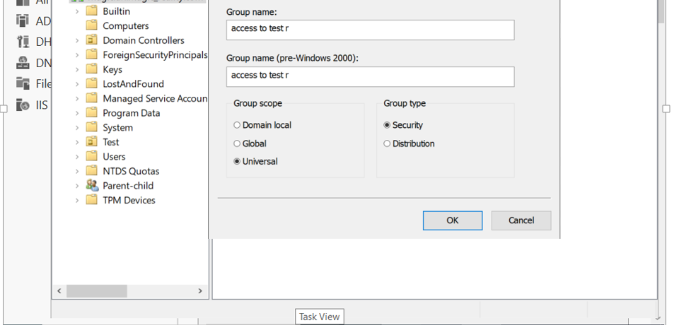

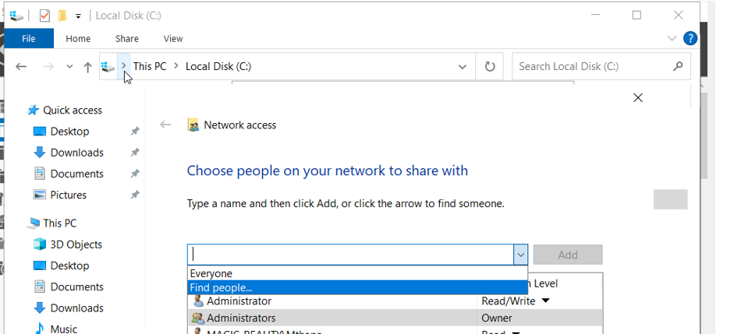

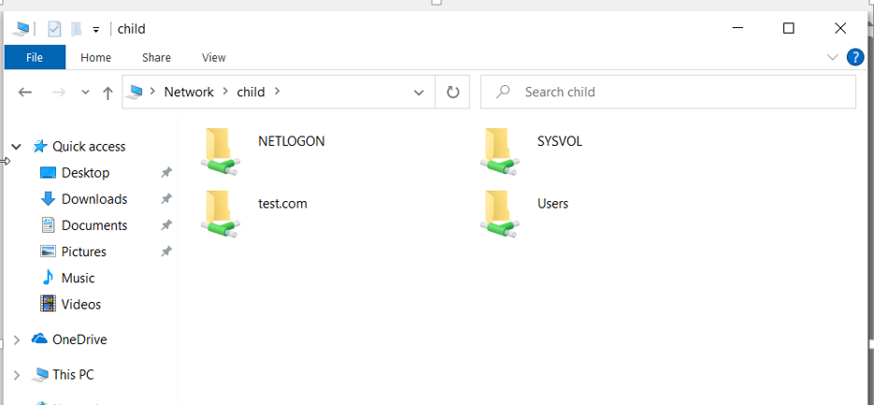

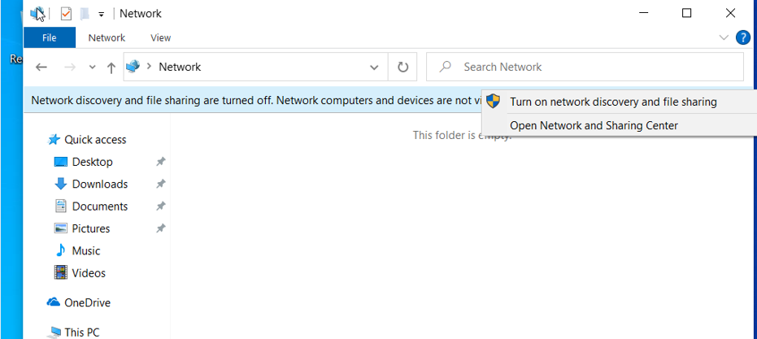

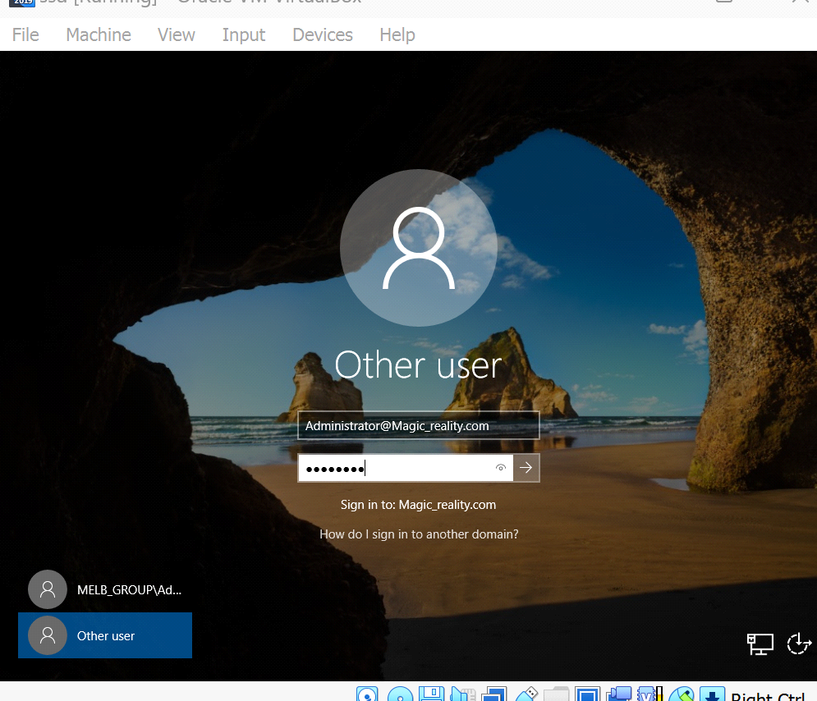

# Table of server

|  |  |  |  |  |
| --- | --- | --- | --- | --- |
| Server | Mac Address | Subnet mask | IP Address | Default Gateway |
| Magic_reality.com | 08-00-27-0E-B9-CF | 255.255.255.0 | 192.168.1.6 | 192.168.1.1 |
| Melb_group | 08-00-27-C5-20-BB | 255.255.255.0 | 192.168.1.5 | 192.168.1.1 |

**Group work contribution table**

This is the group assignment which is allocated to three members. And all the members have equally contributed.

|  |  |  |
| --- | --- | --- |
| Group Members | MIT Student ID | Tasks Allocated |
| Chiran Bhujel | MIT210970 | LAN architecture Planning and description of the network. Web hosting on an IIS server, creation of a system documentation report, and installation of the IIS server. |
| Bibek Lamichhane | MIT213769 | Server installation, Active directory creation and DHCP configuration, delegation control, privilege assignment, SRS Report formatting and references. |
| Gyanendra Gautam | MIT220162 | Creating Organizational unit, Group, users and assigning permissions to them and system documentation report. |

# Conclusion

In conclusion, the Melbourne office of Magic_Reality was able to centralise user authentication, automate IP address assignment, and boost their online presence via website hosting thanks to the LAN infrastructure project. Even though there were obstacles to overcome in terms of complexity, resource allocation, user training, and security, the project was ultimately successful in improving Magic_Reality's network's efficiency, security, and growth possibilities.

# References

|  |  |
| --- | --- |
| [1] | S. a. S. S. .. Simpkins, “"Creating Your Domain.",” *Building a SharePoint 2016 Home Lab: A How-To Reference on Simulating a Realistic SharePoint Testing Environment,* pp. 21-96., 2016. |
| [2] | E. a. E. H. Horley, “"IPv6 and DHCP.",” *Practical IPv6 for Windows Administrators ,* pp. 191-207., 2014. |
| [3] | K. a. K. A. Arya, “ "Group Policy Management Console.",” *Windows Group Policy Troubleshooting: A Best Practice Guide for Managing Users and PCs Through Group Policy,* pp. 31-69, 2016. |
| [4] | B. R. N. J. M. D. a. P. P. Blobel, “"Modelling privilege management and access control.",” *International Journal of Medical Informatics 75, no. 8,* pp. 597-623, 2006. |
| [5] | W. Stanek, “Internet Information Services (IIS) 7.0 Administrator's Pocket Consultant.,” *Microsoft Press.,* 2007 Dec 19. |
| [6] | C. a. H. H. H. Laprade, “"Domain name service trust delegation in cloud computing: exploitation, risks, and defense.",” *In Proceedings of the 37th ACM/SIGAPP Symposium on Applied Computing,* pp. pp. 13-21., 2022. |